Diving into the Wildlife Wonders and Marine Magic of the Galapagos

5 DAYS / 4 NIGHTS - M/C ALYA

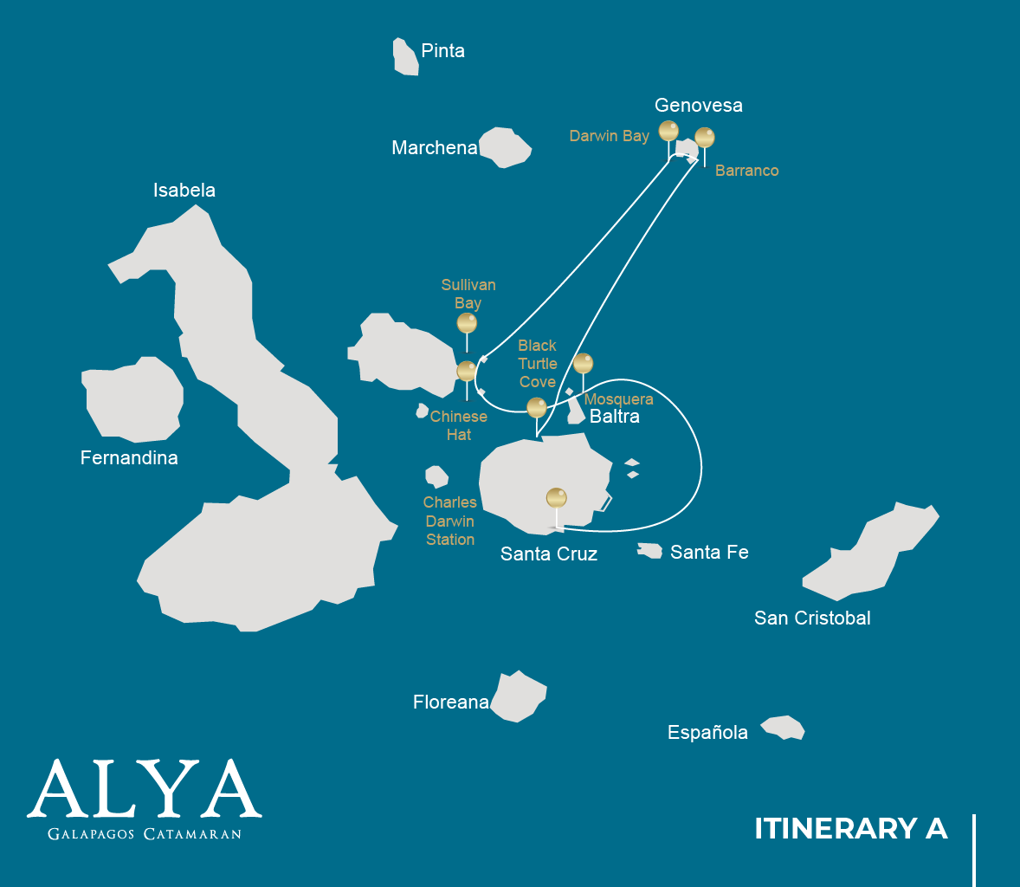

 |  |  |  | HIKING | SNORKEL | PANGA RIDE | PADDLE BOARD | KAYAK
5 DAYS CRUISE "A" | THURSDAY | PM | Santa Cruz: Black Turtle Cove |  |  | •
 | FRIDAY | AM | Genovesa: Darwin Bay | • | • | • | • | •
 |  | PM | Genovesa: El Barranco | • | • | • | • | •
 | SATURDAY | AM | Santiago: Sullivan Bay | • | • | •
 |  | PM | Bartolome: Bartolome | • | • | •
 | SUNDAY | AM | Santiago: Chinese Hat | • | • | • | • | •
 |  | PM | Mosquera: Mosquera Islet | • | •
 | MONDAY | AM | Santa Cruz: Charles Darwin Station | •

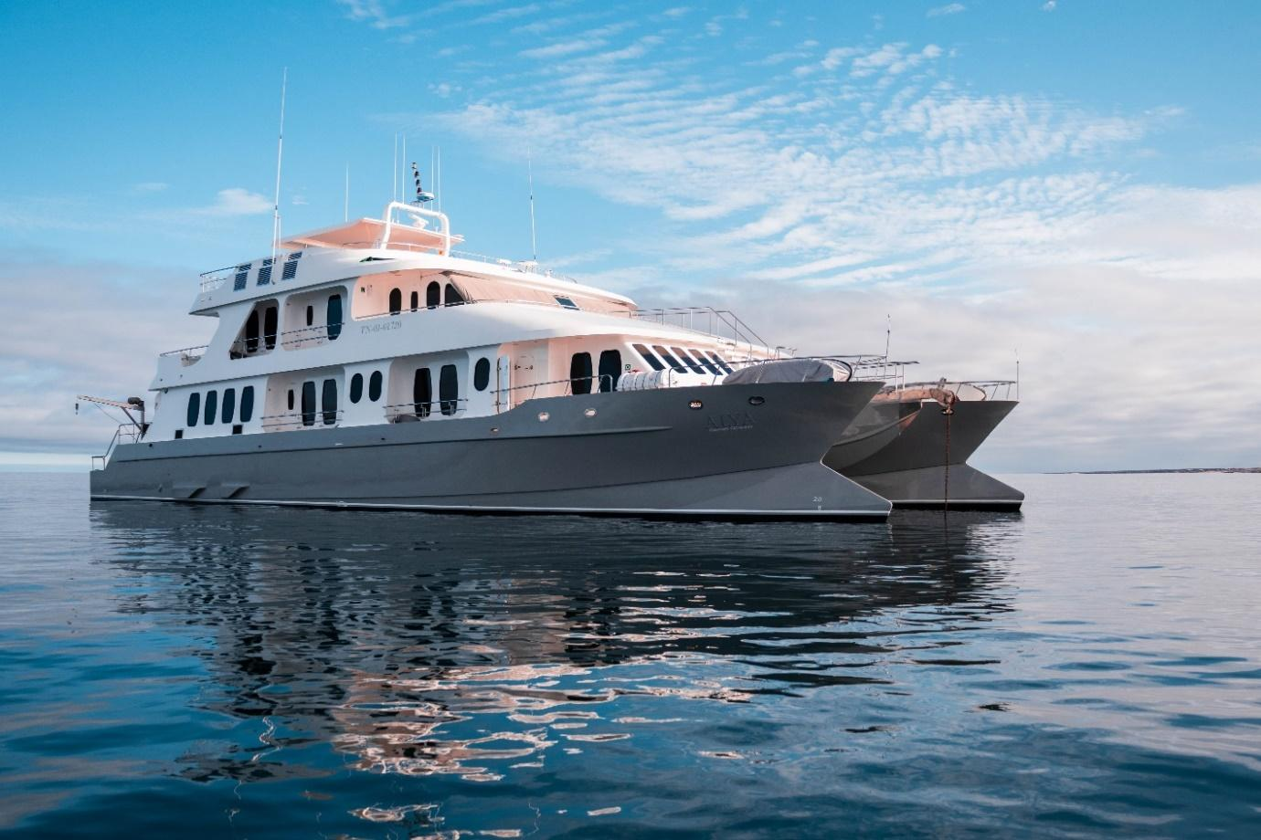

DAY 1

AM: ARRIVAL AT BALTRA AIRPORT
Your voyage to the captivating Galapagos Islands commences! Upon your arrival at Baltra Airport, you'll be greeted by our National Park-certified naturalist guide, ready to introduce you to the unique wonders of this pristine archipelago.

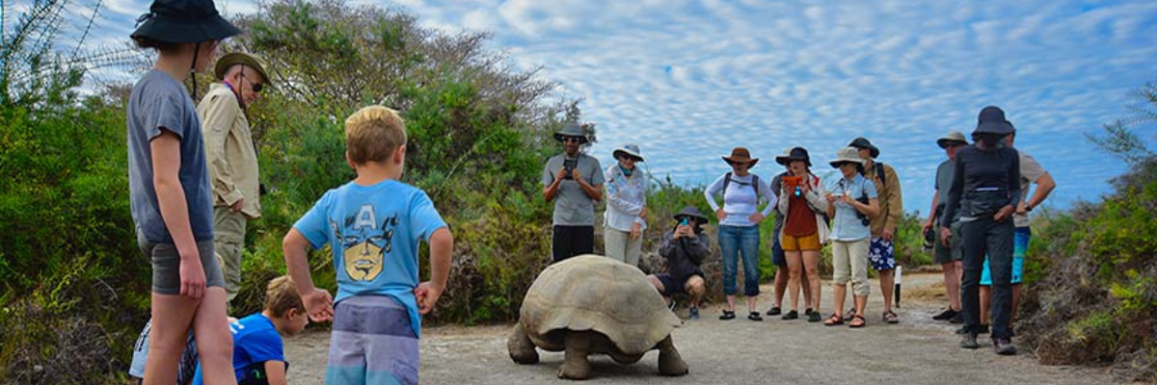

PM: BLACK TURTLE COVE
We dive into our Galapagos adventure at Black Turtle Cove, aptly named for the thriving "Tortugas negras" population or green sea turtles. We navigate this natural sanctuary on dinghies, cruising amidst serene mangrove forests and tranquil water channels. Expect sightings of reef sharks, diverse ray species, and a plethora of bird species, including herons, pelicans, and boobies. Remember, this magical cove is a significant breeding ground for turtles and a nursery for various shark species!
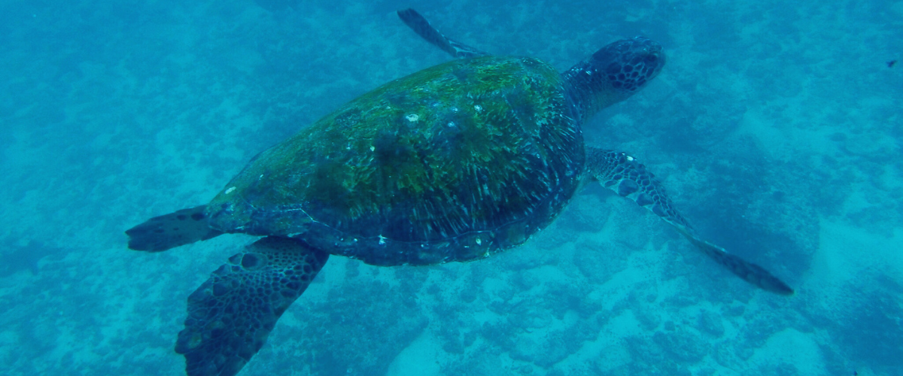
Highlights: White-tipped and black-tipped reef sharks, green sea turtles, rays, herons, blue-footed boobies, and mangroves.

Meals | L / D
Level | 1
Activities | Panga Ride

DAY 2

AM: DARWIN BAY
Start your day surrounded by the bustling avian life of Darwin Bay on Genovesa Island, a birdwatcher's paradise. As soon as your feet touch the sandy terrain, you're welcomed by a symphony of seabird calls, with frigatebirds, boobies, and gulls soaring overhead or nestled in the foliage. The trail meanders through colonies of sea lions, marine iguanas, night herons, Darwin finches, Galapagos doves, mockingbirds, and more.

Snorkeling Experience: Dive into the bay's underwater realms, teeming with vibrant fish, elusive sharks, graceful rays, and playful sea lions. With multiple snorkeling spots, from cliff-lined deep waters to shallow beachside areas, you're guaranteed a spectacular aquatic show.

Highlights: Nesting great frigatebirds, red-footed & Nazca boobies, Galapagos sea lions, lava & swallow-tailed gulls, yellow-crowned night herons, Genovesa ground finch, Genovesa cactus finch, Galapagos mockingbirds.

Trail | 1,2 km / 0,7 mi
Level | 3
Activities | Wet landing and hiking

PM: EL BARRANCO
Next stop, El Barranco. Known for its fractured lava cliffs serving as the perfect dwelling for storm petrel colonies, this unique ecosystem draws a significant population of short-eared owls. A trail alongside these cliffs reveals red-footed and Nazca boobies aplenty. Resting in the shadows at the cliffs' base, you may spot Galapagos fur seals and numerous seabirds.

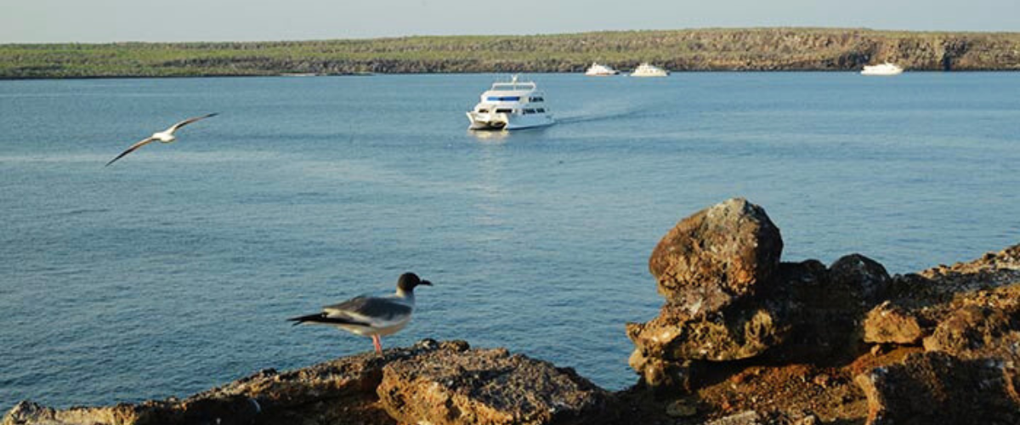

Snorkeling Experience: The deep blue waters along the cliffs offer another underwater escapade with a profusion of colorful fish, sharks, rays, and sea lions.

Highlights: Nesting great frigatebirds, red-footed & Nazca boobies, Galapagos sea lions, Galapagos fur seals, lava & swallow-tailed gulls, yellow-crown night herons, Genovesa ground finch, Genovesa cactus finch, Galapagos mockingbirds.

Meals | B / L / D
Trail | 1,2 km / 0,7 mi
Level | 3
Activities | Dry landing and hiking

DAY 3

AM: SULLIVAN BAY
Step back in time at Sullivan Bay, an open book to the volcanic birth of these islands. Traverse the well-preserved Pahoehoe lava field, studying its delicate, unique textures. The seemingly lifeless landscape gradually unveils a resilience of nature, with pioneer plants, lava lizards, and tiny birds emerging on careful observation. Keep your eyes on the shoreline for resident penguins, pelicans, and oystercatchers.

Snorkeling Experience: A dip in the water here starkly contrasts the barren land. The coral sand beach and the dinghy access point reveal a marine world with fish schools, Galapagos penguins, reef sharks, turtles, and rays.

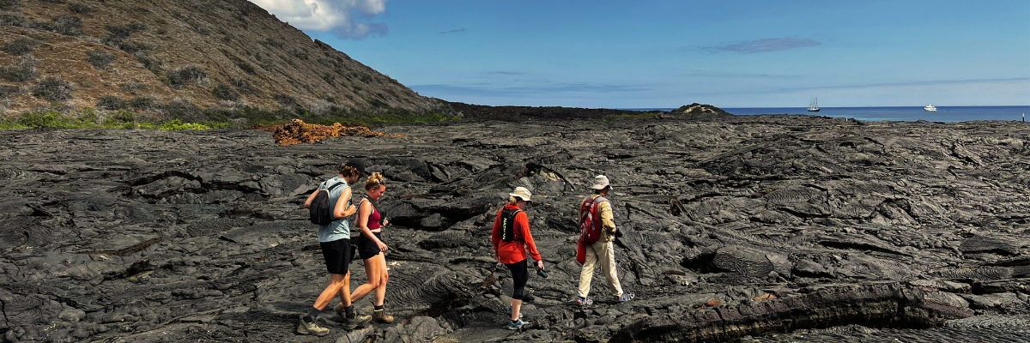

Highlights: Pahoehoe lava, Galapagos penguins, oystercatchers, Galapagos hawks.

Trail | 2,2 km / 1,4 mi
Level | 5
Activities | Dry landing and hiking

PM: BARTOLOME
Stand atop Bartolome Island for unparalleled views of the lunar-like landscape, punctuated by scattered volcanic cones, Pinnacle Rock, and the bay of Sullivan. Bartolome is a jewel in the Galapagos crown and home to a vibrant population of penguins.

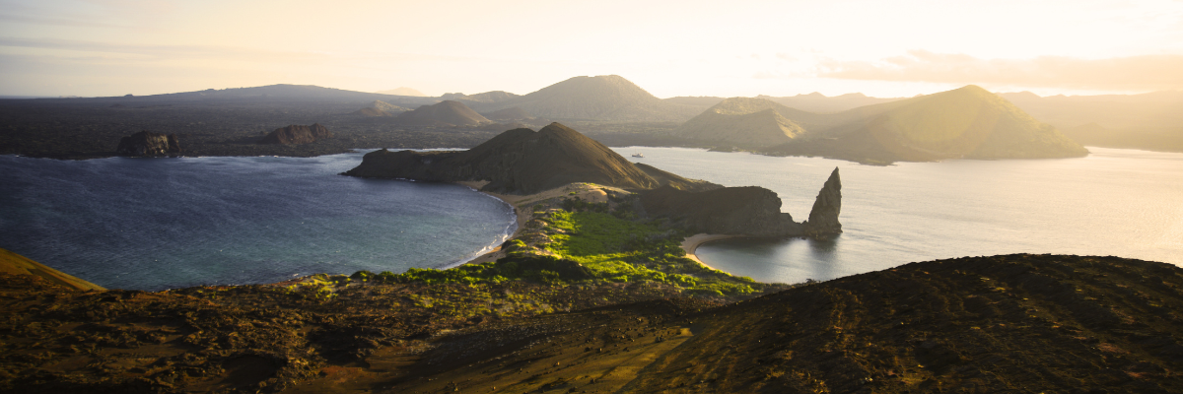

Snorkeling Experience: A swim or snorkel from the beach opens up an underwater playground renowned in the Galapagos. Penguins, a multitude of fish, colorful invertebrates, sea lions, turtles, rays, and reef sharks make this snorkeling experience unforgettable.

Highlights: Galapagos penguins, volcanic landscapes, Pinnacle rock, blue-footed boobies, herons, sea lions, sharks.

Meals | B / L / D
Trail | 1,5 km / 0,9 mi
Level | 2
Activities | Dry landing and hiking

DAY 4

AM: CHINESE HAT
Welcome to the perfectly symmetrical volcanic cone of Chinese Hat! Separated from Santiago by a slender channel, this idyllic islet is framed by turquoise waters, coral sand beaches, and dark lava rocks – an unexpected haven for penguins. A shore trail brings you up close to a small colony of sea lions.

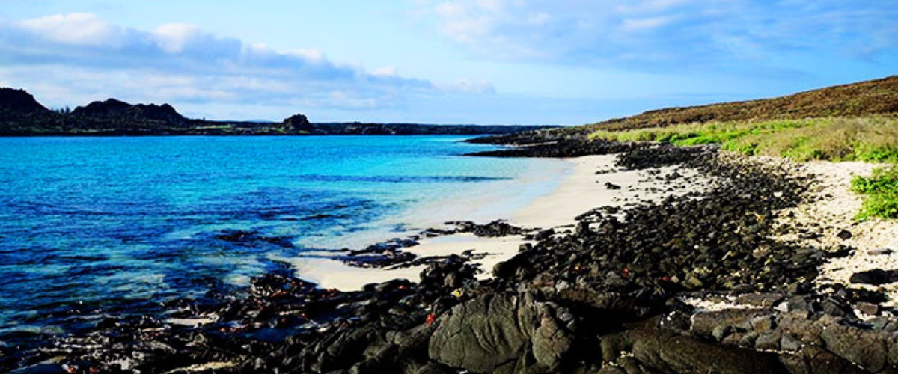

Snorkeling Experience: Experience a world of vividly colored fish, sleek reef sharks, and perhaps a swift penguin chasing after a school of anchovies. It's a mesmerizing underwater spectacle you want to take advantage of.

Highlights: Galapagos sea lions, Galapagos penguins, lava tubes, oystercatchers, Galapagos hawks.

Trail | 1,3 km / 0,8 mi
Level | 3
Activities | Wet landing and hiking

PM: MOSQUERA
Our afternoon destination is Mosquera, largely a barren sand bar with rocky outcrops and salt-resistant vegetation. Stroll along the beach, observing the playful antics of sea lion pups in the surf and tide pools. Keep an eye out for endemic lava gulls, often spotted in mid-flight hunting for their next meal.

Snorkeling Experience: Given favorable wave conditions, snorkel at the northern tip of the island or one of the smaller, sheltered beaches for another immersive marine encounter.

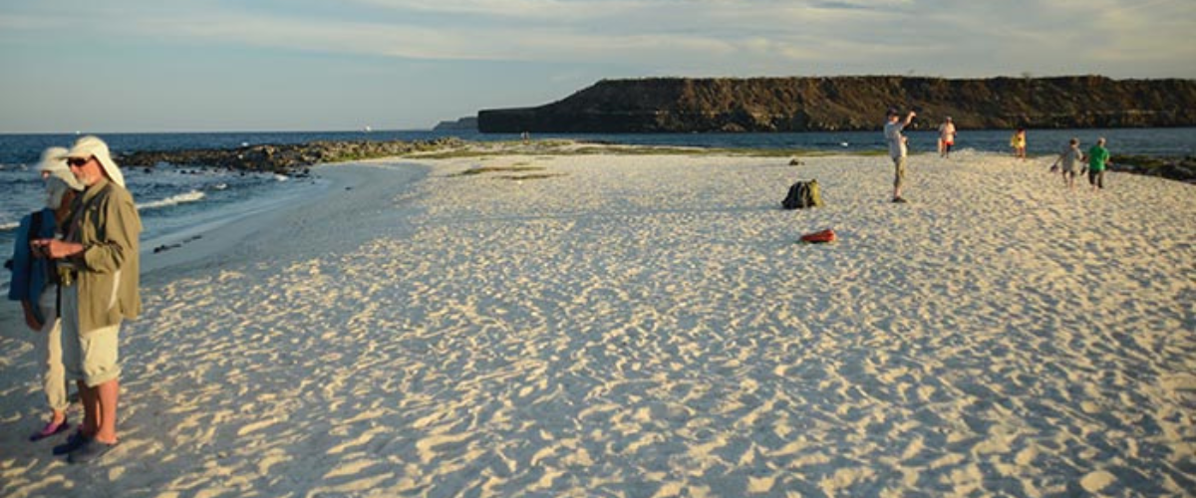

Highlights: Galapagos sea lions, lava gulls, oystercatchers, shorebirds,

Meals | B / L / D
Trail | sandy area of 0,6 km / 0,4mi
Level | 1
Activities | Wet landing and hiking

DAY 5

AM: CHARLES DARWIN STATION
Spend your morning at the renowned Charles Darwin Station. As a nonprofit organization working closely with the Galapagos National Park, the station is committed to the preservation and study of the archipelago's biodiversity. Discover the myriad initiatives underway to safeguard native species and combat invasive threats to the Galapagos ecosystem. This visit offers the unique opportunity to see giant tortoises bred in captivity.

Highlights: Galapagos giant tortoise & land iguanas breeding program, Darwin finches, Galapagos mockingbirds, Galapagos flycatchers, yellow warblers.

Following your visit to the Charles Darwin Station, you will be transferred to the airport for your flight back to mainland Ecuador, concluding your unforgettable Galapagos journey.

Meal | B
Trail | 2 km / 1,2 mi
Level | 1
Activities | Dry landing and hiking

Glossary

Meals | Breakfast | B
 | Lunch | L
 | Dinner | D
Hiking Effort | Level 1 | Easy
 | Level 2 | Moderate
 | Level 3 | Hard

