Immerse in Nature's Grandeur: A Wildlife Expedition across the Galapagos

6 DAYS / 5 NIGHTS – M/C ALYA
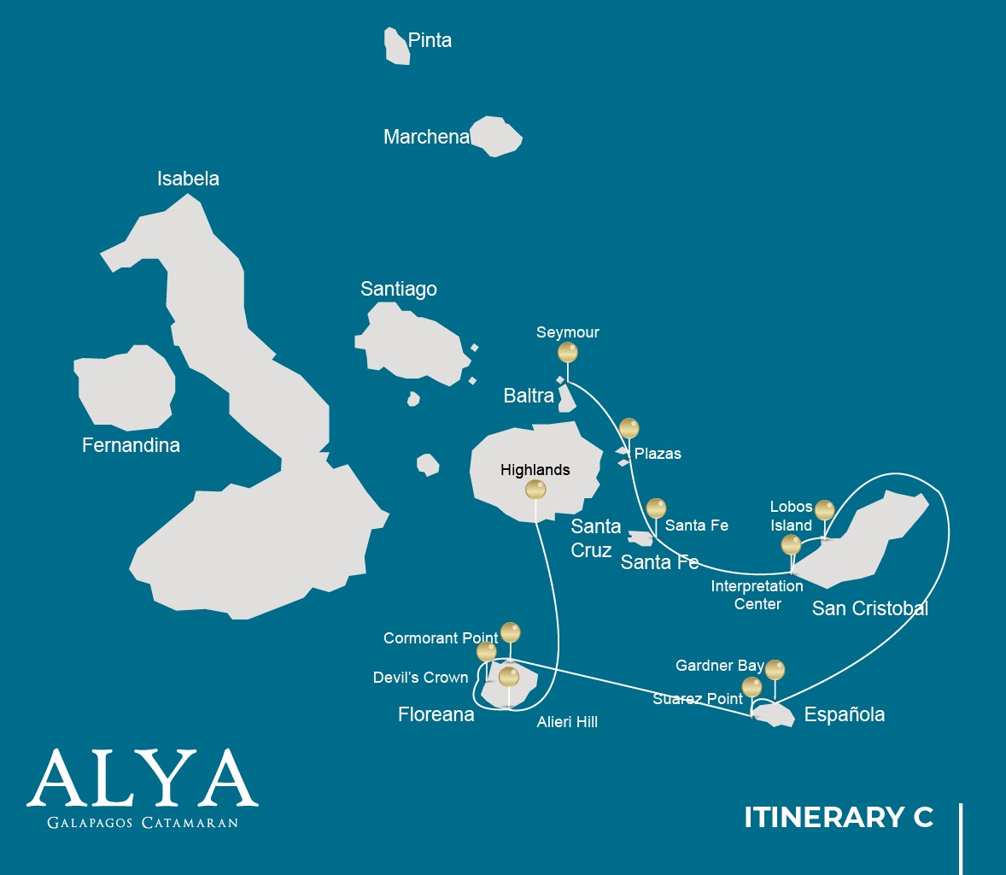

 |  |  |  | HIKING | SNORKEL | PANGA  RIDE | PADDLE  BOARD | KAYAK
6 DAYS CRUISE "C" | MONDAY | PM | Seymour: Seymour | • | • | •
 | SUNDAY | AM | Plazas: Plazas | •
 |  | PM | Santa Fe: Santa Fe | • | • | • | • | •
 | MONDAY | AM | San Cristobal:  Interpretation Center / Kicker Rock | • | • | •
 |  | PM | Lobos Island: Lobos  Island | • | • | •
 | TUESDAY | AM | Española: Gardner Bay |  | • | • | • | •
 |  | PM | Española: Suarez Point | •
 | WEDNESDAY | AM | Floreana: Cormorant  Point / Devil's´Crown | • | • | •
 |  | PM | Floreana: Alieri Hill | •
 | THURSDAY | AM | Santa Cruz: Highland | •

DAY 1

AM: ARRIVAL AT BALTRA AIRPORT
Your voyage to the captivating Galapagos Islands commences! Upon your arrival at Baltra Airport, you'll be greeted by our National Park-certified naturalist guide, ready to introduce you to the unique wonders of this pristine archipelago.
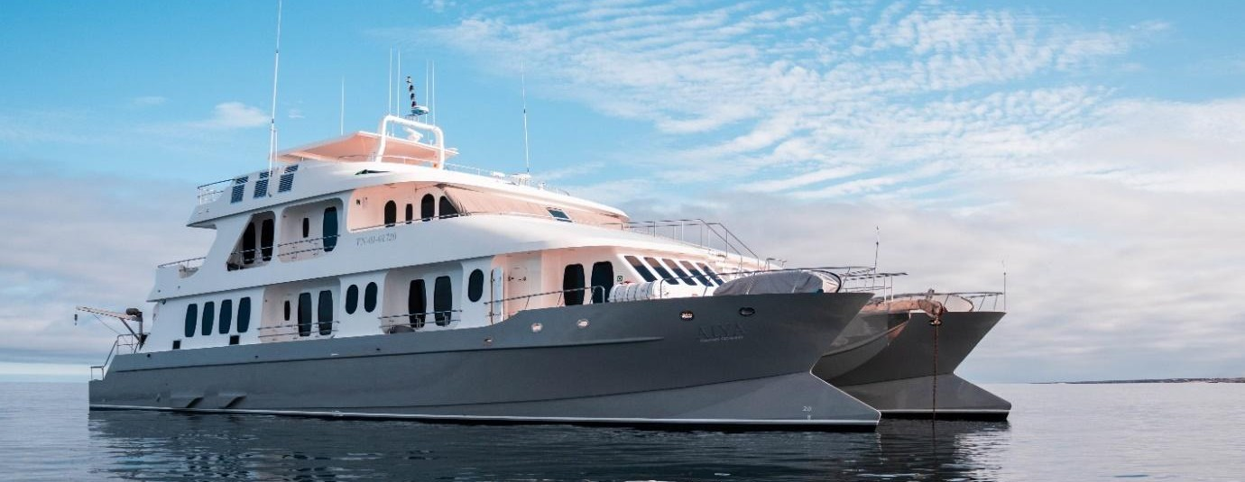

PM: SEYMOUR
Immerse in the abundant wildlife of Seymour Island. Watch out for magnificent and great frigatebirds displaying their fascinating courtship ritual. Observe blue-footed boobies in their nesting grounds and catch a glimpse of land and marine iguanas in their natural habitat. Delight in the playful activities of sea lions in the surf.

Snorkeling Experience: Dive into the azure waters teeming with diverse fish species, sea lions, sharks, eels, turtles, rays, and many more. Seymour Island is a fantastic snorkeling spot not to be missed.

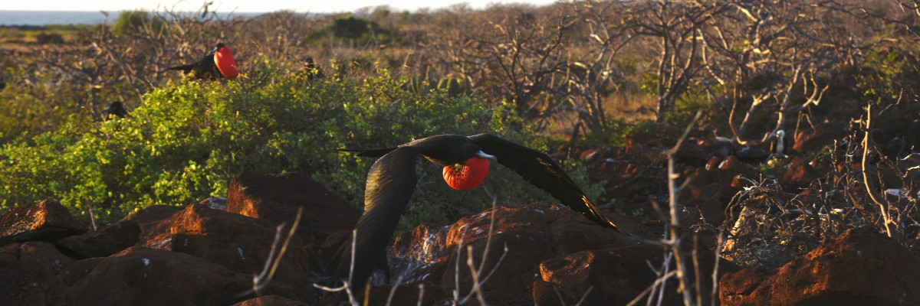
Highlights: Galapagos sea lions, blue footed boobies, magnificent & great frigatebirds, land & marine iguanas, swallow-tailed gulls, shearwaters, Darwin finches.

Meals | L / D
Trail | 1,4 km / 0,8 mi
Level | 1
Activities | Dry landing and hiking

DAY 2

AM: PLAZAS
Discover the richness of South Plazas, where land iguanas feed on prickly-pear cacti and playful sea lion pups frolic in tide pools. Walk along the cliff trail and witness the flurry of sea birds such as frigatebirds, red-billed tropicbirds, boobies, swallow-tailed gulls, and pelicans.
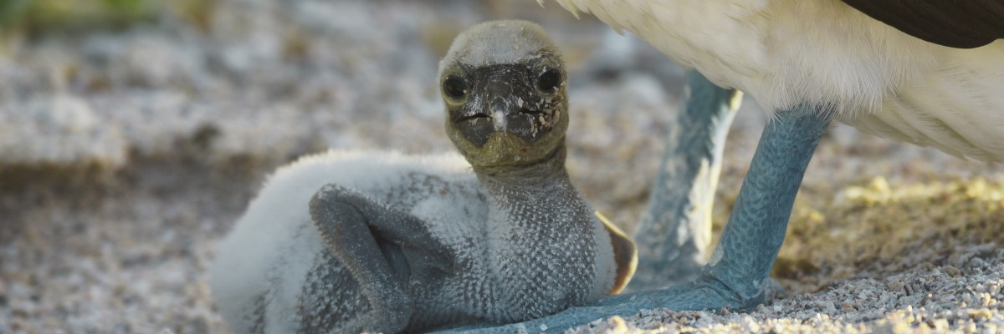

Highlights: Galapagos land iguanas, sea lions, tropicbirds, pelicans, boobies, Galapagos shearwaters, swallow-tailed gulls.

Trail | 1,4 km / 0,8 mi
Level | 2
Activities | Dry landing and hiking

PM: SANTA FE
Explore the cactus-strewn, lava-rock landscapes of Santa Fe. See sea lions basking in the white sand beaches, and keep an eye out for Galapagos hawks, Darwin finches, Galapagos doves, mockingbirds and lava lizards.
Snorkeling Experience: Enjoy a soothing swim, kayak or snorkel in the bay's sheltered waters where sea lion pups, reef sharks, sea turtles, rays, surgeonfish and parrotfish await you.
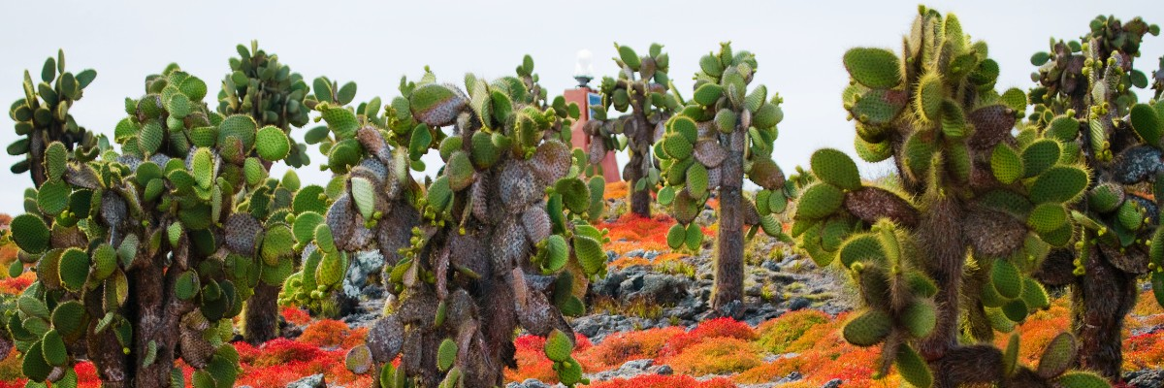

Highlights: Giant cactus, Santa Fe bay, Galapagos sea lions, Santa Fe land iguanas, Galapagos hawks, Galapagos doves, reef sharks.

Meals | B / L / D
Trail | 0,8 km / 0,5 mi
Level | 2
Activities | Wet landing and hiking

DAY 3

AM: INTERPRETATION CENTER
Engage in the rich history of the Galapagos at the Interpretation Center, tracing back from the era of early Spanish explorers to the present day, and learn about the challenges faced by the initial settlers.

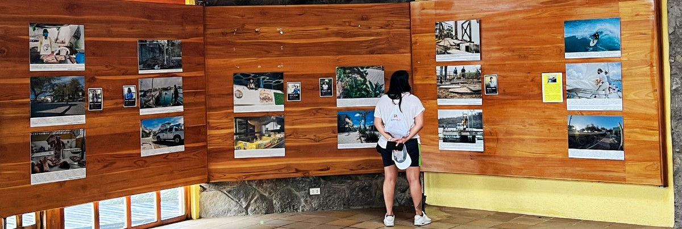

Highlights: Endemic plants, and an exhibition on human history

Trail | 0,2 km / 650 ft
Level | 1
Activities | Dry landing and hiking

PM: LOBOS ISLAND
Witness the bustling wildlife of Lobos Island, home to large groups of sea lions, male frigatebirds, and blue-footed boobies.

Snorkeling Experience: The calm waters of Lobos Island offer an excellent snorkeling experience. Swim with playful sea lions, or spot sea turtles and rays resting in the sandy bottoms.
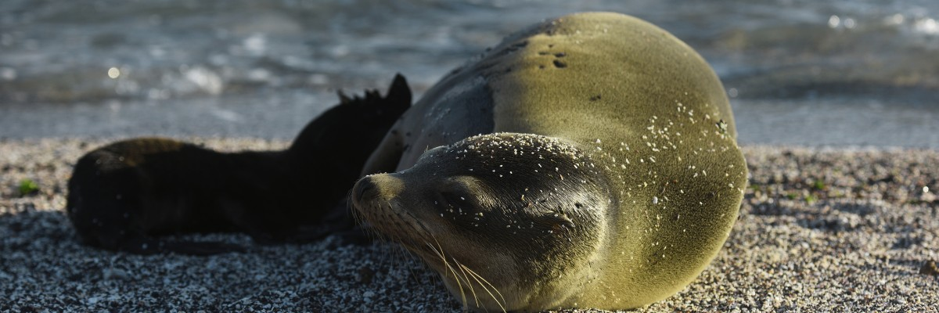

Highlights: Galapagos sea lions, marine Iguanas, magnificent & great frigatebirds, blue-footed Boobies, San Cristobal Lava Lizards.

Meals | B / L / D
Trail | 0,6 km / 0,4 mi
Level | 3
Activities | Dry landing

DAY 4

AM: GARDNER BAY
Stroll along the stunning Gardner beach, known for its fine coral sand, turquoise water, and an array of endemic species such as Española mockingbirds, marine iguanas, and Galapagos hawks.

Snorkeling Experience: Dive into the vibrant marine world at Gardner Bay. Expect to see sea lions, reef sharks, rays, and many species of fish, including Angelfish, Parrotfish, Damselfish, Surgeonfish, and more.
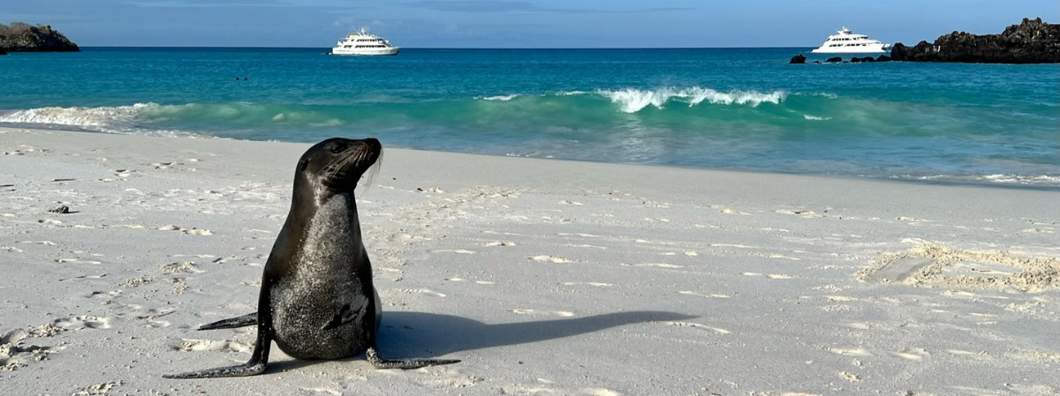

Highlights: Coral sand beach, sea lions, Galapagos hawks, Española mockingbirds, Darwin finches, marine iguanas.

Trail | 0,8 km / 0,5 mi
Level | 1
Activities | Wet landing and hiking

PM: SUAREZ POINT
The Suarez Point itinerary has been changed since September 20, 2023, due to a contingency
conservation plan for the species on this island. By the authorization of the Galapagos National Park, only a 360-degree panga tour around the island will be allowed.
This itinerary will return to normal once the Galapagos National Park deems it optimal for welcoming guests again.

Experience an awe-inspiring nature walk at Suarez Point. Encounter sea lions, marine iguanas, and large colonies of sea birds, and from April to January, catch a sight of the waved albatross, the largest bird on the islands.
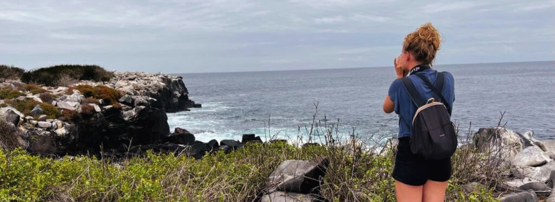

Highlights: Sea lions, Waved Albatross, Galapagos hawks, Española mockingbirds, Darwin finches, marine iguanas, Nazca & Blue-footed Boobies, Red-billed Tropicbirds, Swallow-tailed gulls, herons, lava lizards, herons.

Meals | B / L / D
Trail | 1,7 km / 1,1 mi
Level | 3
Activities | Dry landing

DAY 5

AM: CORMORANT POINT / DEVIL´S CROWN
Venture into Punta Cormorant, famous for its large coastal lagoon inhabited by American flamingoes, white-cheeked pintails, black-necked stilts and other shorebirds.

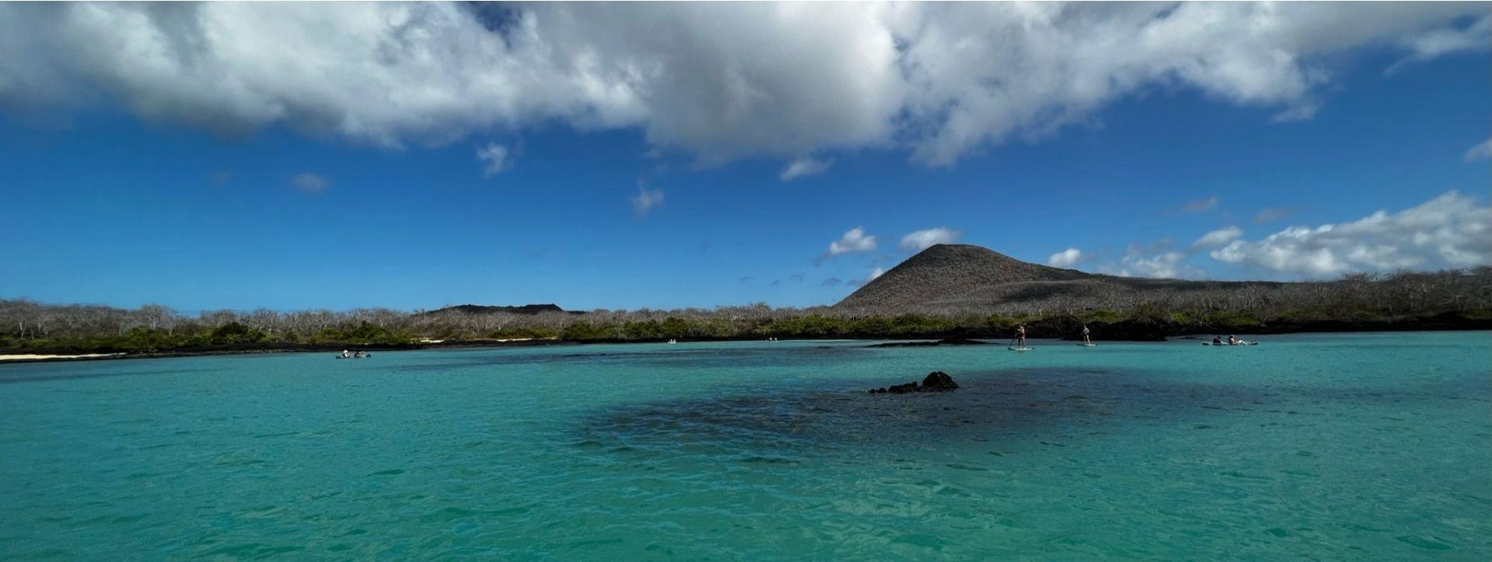

Snorkeling Experience: Prepare for an exhilarating snorkeling experience at Devil’s Crown. Be amazed by the abundant marine life, including snapper, Creole fish, parrot fish, angelfish, reef sharks, sea turtles, and rays.

Highlights: American flamingo, blue-footed booby, frigatebirds, tropicbirds, Galapagos shearwaters, sea lions, sea turtle nesting site, finches, shorebirds, coral-sand beach.

Trail | 1,6 km / 1 mi
Level | 1
Activities | Wet landing and hiking

PM: ALIERI HILL
End your day at Alieri Hill, a paradise for plant lovers boasting unique endemic species and breathtaking views of the northern coast. Keep an eye out for flycatchers, yellow warblers, and Darwin finches.

Highlights: Endemic plants, transition zone, Darwin finches.

Meals | B / L / D
Trail | 1 km / 0,6 mi
Level | 3
Activities | Dry landing and hiking

DAY 6

AM: HIGHLANDS
Travel to the lush highland forests, home to Galapagos Giant tortoises casually grazing and resting in freshwater ponds. Look out for rare bird species such as finches, flycatchers and water birds. Visit a lava tunnel and learn about their formation from ancient volcanic eruptions. After this visit, you will be transferred to the airport for your flight back to continental Ecuador.
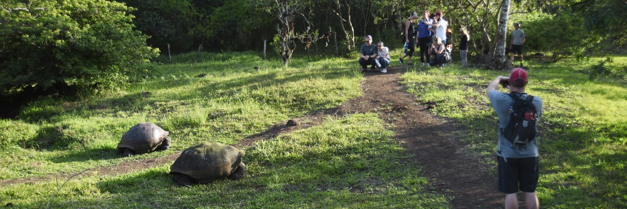

Following your visit to the ranch in the highlands, you will be transferred to the airport for your flight back to mainland Ecuador, concluding your unforgettable Galapagos journey.

Highlights: Giant tortoises, Darwin finches, barn owls, white-cheeked pintails, Galapagos flycatchers, Lava tunnels.

Meals | B
Trail | 1-1,5 km / 0,6-0,9 mi
Level | 1
Activities | Dry landing and hiking

GLOSSARY
Meals | Breakfast | B
 | Lunch | L
 | Dinner | D
Hiking Effort | Level 1 | Easy
 | Level 2 | Moderate
 | Level 3 | Hard

