GALAPAGOS ONBOARD A CRUISE

5 DAYS / 4 NIGHTS YACHT BONITA
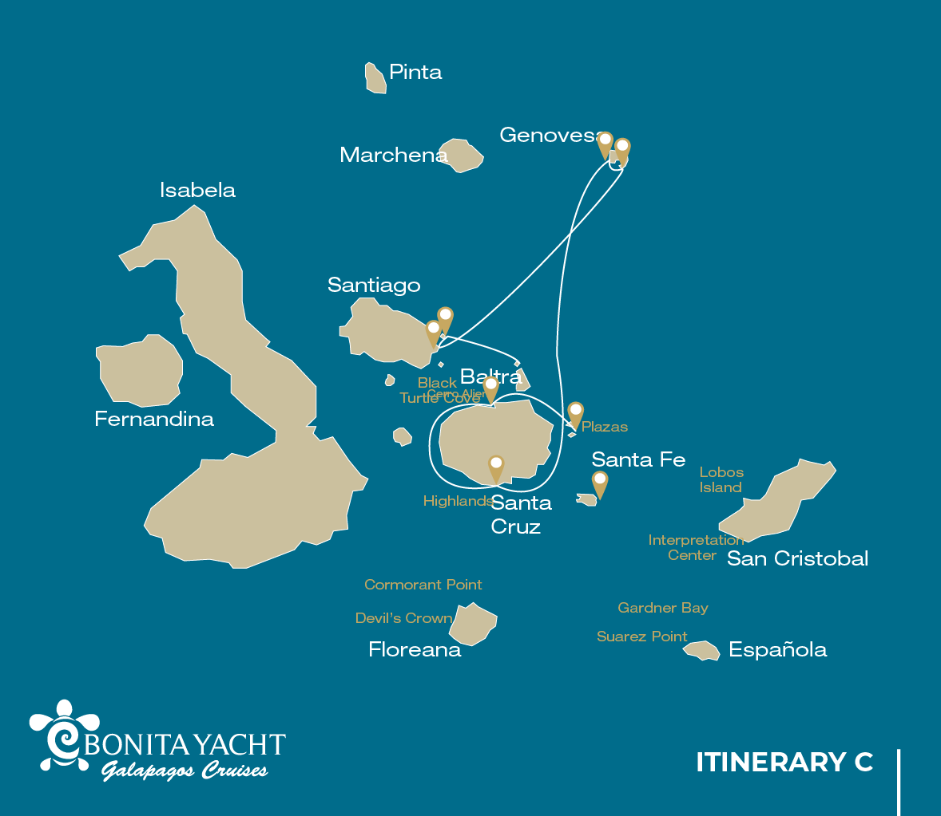

 |  |  |  | HIKING | SNORKEL | PANGA RIDE | PADDLE BOARD | KAYAK
5 DAYS CRUISE "C" | WEDNESDAY | PM | Plazas: Plazas | •
 | THURSDAY | AM | Santa Cruz: Black Turtle Cove |  |  | •
 |  | PM | Santa Cruz: Highlands | •
 | FRIDAY | AM | Genovesa: Darwin Bay | • | • | • | • | •
 |  | PM | Genovesa: El Barranco | • | • | • | • | •
 | SATURDAY | AM | Santiago: Sullivan Bay | • | •
 |  | PM | Bartolome: Bartolome | • | • | •
 | SUNDAY | AM | Seymour: Seymour | •

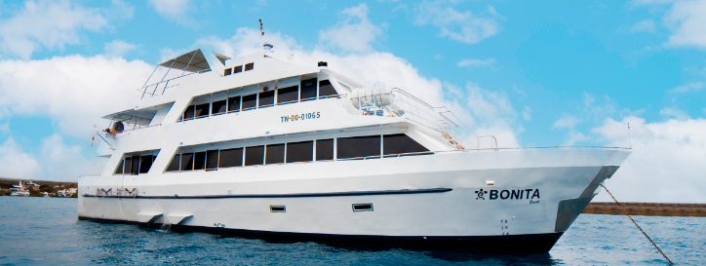

DAY 1
AM: BALTRA AIRPORT
Departure to the Galapagos Islands, arrival at Baltra airport, where our naturalist guide of the National Park will be waiting for you.
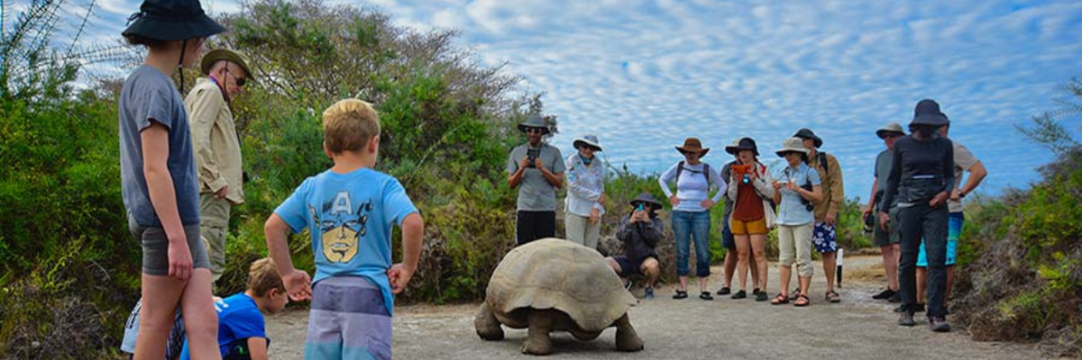

PM: PLAZAS
Of the two twin islands, only South Plazas is allowed to be visited, while North plazas is kept exclusively for scientific research. This is a small islet, but it packs an impressive amount of wildlife. Right after you land you will see Galapagos land iguanas waiting under prickly-pear cactus feed on their fruits. A large colony of sea lions will give you the opportunity to see playful pups enjoying the tide pools, but also large grumpy males defending their territories. The trail will take you to a cliff where you can observe many sea birds, such as frigatebirds, red-billed tropicbirds, boobies, swallow-tailed gulls and pelicans. A reddish succulent vegetation with scattered cactus covers most of the islands like a carpet, giving this island a unique personality.
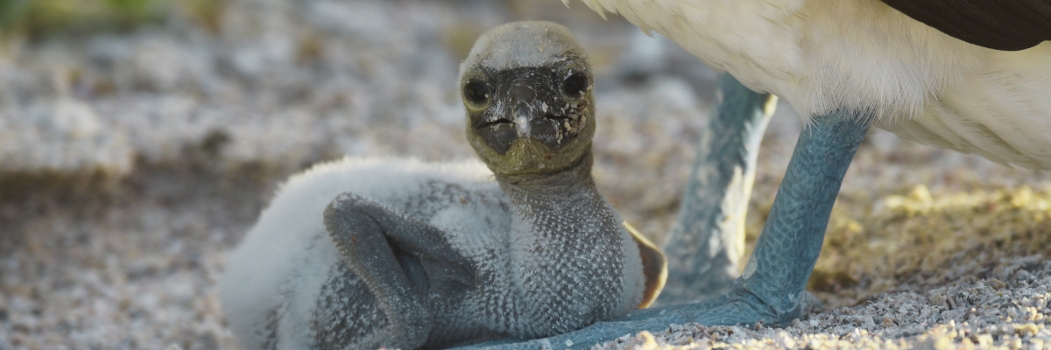
Highlights: Galapagos land iguanas, sea lions, tropicbirds, pelicans, boobies, Galapagos shearwaters, swallow-tailed gulls.
Trail | 1,4 km / 0,8 mi
Meals | L/D
Level | 2
Activities | Dry landing and hiking

DAY 2
AM: BLACK TURTLE COVE
Black Turtle Cove gets its name from the abundance of green sea turtles, locally known as: “tortugas negras”. There is no landing here so you will be doing a boat tour on the dinghies, exploring shallow channels and small coves surrounded by beautiful mangrove forests. Reef sharks, sea turtles and several species of rays inhabit this beautiful area which is considered an important mating area for turtles and a nursery for several species of sharks. Herons, pelicans and boobies are also common here as they pray in schools of anchovies.
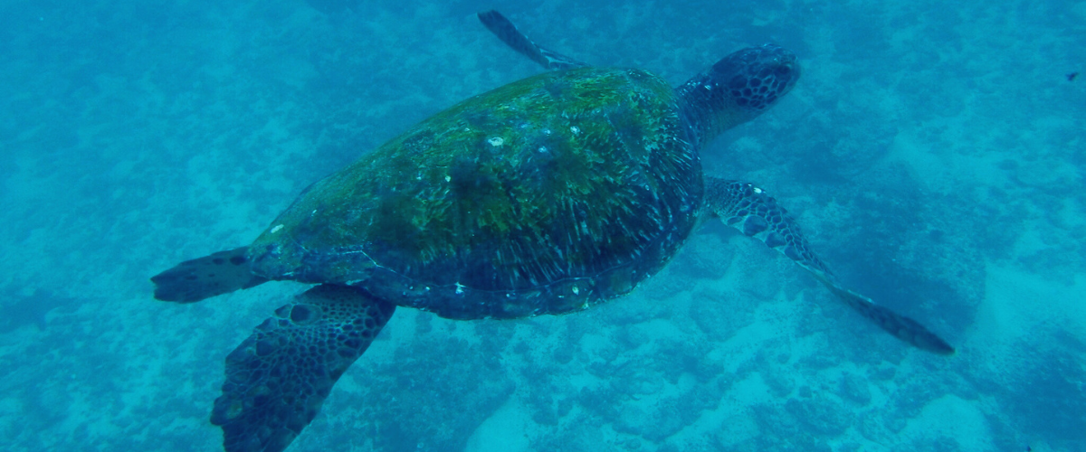
Highlights: White-tipped and black-tipped reef sharks, green sea turtles, rays, herons, blue-footed boobies, mangroves.
Level | 1
Activities | Panga Ride

PM: HIGHLANDS
Either if you do this visit starting from Baltra or from Puerto Ayora, a bus will take you to the highlands stopping along the way at one of the reserves to visit the lush highland forests where you will look for Galapagos Giant tortoises in their natural environment. This is the best place in the Galapagos to see these gentle giants (reaching over 300 kg / 600 pounds!) casually grazing and resting in freshwater ponds. This is also home for a great diversity of birds rarely found at the lowlands, including finches (tree, woodpecker and vegetarian finches), flycatchers and several species of water birds. You will visit a lava tunnel (depending on the itinerary) and learn how these extraordinary formations were created by ancient volcanic eruptions.
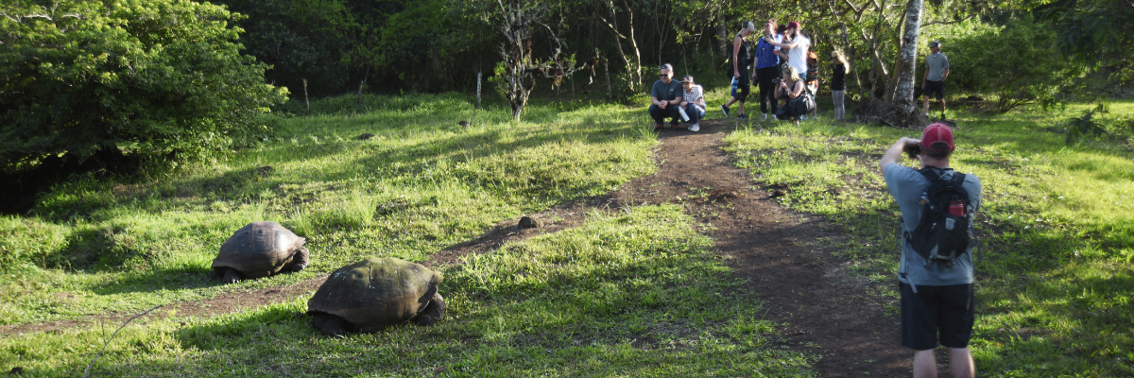
Highlights: Giant tortoises, Darwin finches, barn owls, white-cheeked pintails, Galapagos flycatchers, Lava tunnels.
Meals | B /L/D
Trail | 1-1,5 km / 0,6-0,9 mi
Level | 1
Activities | Dry landing and hiking

DAY 3
The itinerary of Genovesa, Darwin Bay, and El Barranco, established on this day, has been changed on September 20, 2023, by the Galapagos National Park Directorate (GNPD) due to a Contingency Plan for the Conservation of Species on this island. In its place, visits will be made to the neighboring islands based on the authorization of the Galapagos National Park.
This itinerary will return to normal when the GNPD considers it optimal for the reception of passengers again on Genovesa Island.

AM: EDEN ISLET
Eden Islet, true to its biblical name, evokes a paradisiacal oasis. Located near Santa Cruz Island, this tiny isle boasts heavenly beaches and crystal-clear waters reminiscent of the quintessential "deserted island." With a diameter of just 600 meters and its highest point reaching 77 meters, its small size is juxtaposed with its immense charm, home to nine turtle species.
Snorkel: Marvel at the sea stars that cover the ocean floor and the endemic fish, like the white-tailed damselfish, that call it home.
Highlights: Striped burrfish, reef sharks, blue-footed boobies, and Nazca boobies

Meals | B / L / D
Level | 1
Activities | Snorkeling and Panga ride

PM: CHINESE HAT
This small islet is formed by a volcanic cone with a perfectly symmetrical shape. It is separated from Santiago by a narrow channel, creating one of the most beautiful bays on the islands. Blue-turquoise water and coral sand beaches surrounded by dark lava rocks give this area a real tropical character, which makes it even more surprising to find penguins resting in the rocks. The trail goes along the shore, taking you through a small colony of sea lions.
Snorkel: When you swim in this place, you will get mesmerized by the incredible colors of the fish and the sleek silhouette of reef sharks, and it is not uncommon to see a penguin darting through the water chasing anchovies like a tiny torpedo.
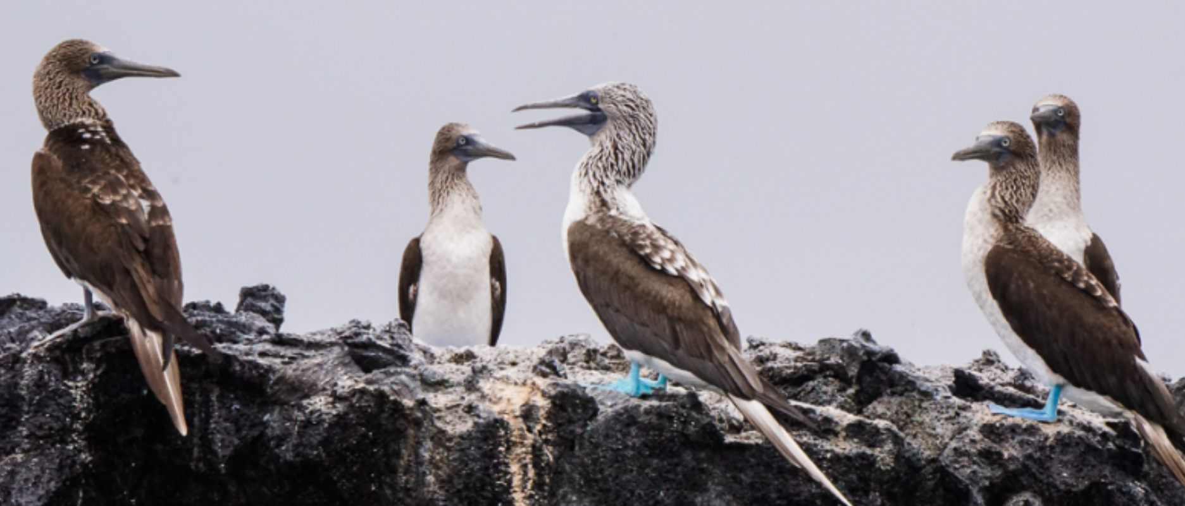
Highlights: Galapagos sea lions, Galapagos penguins, lava tubes, oystercatchers, Galapagos hawks
Trail | 1.3 km / 0,8 mi
Meals | B/L/D
Level | 3
Activities | Wet landing and hiking

DAY 4
AM: SULLIVAN BAY
This hike is a journey into understanding the birth of these volcanic islands. You will walk in a very well preserved flow of Pahoehoe lava, which will give you endless opportunities to see the delicate textures of these types of lavas which only appear in a few places throughout the world. At first sight the barren landscape looks completely deprived of life, but look carefully for pioneer plants, lava lizards and small birds. By the shore, you can find penguins, pelicans and oystercatchers.
Snorkel: You will have the option to swim or snorkel from a coral sand beach or from the dinghies. Getting underwater is like traveling to another world: if the land is almost lifeless, the sea is teaming with life, including large schools of fish, Galapagos penguins, reef sharks, turtles and rays.
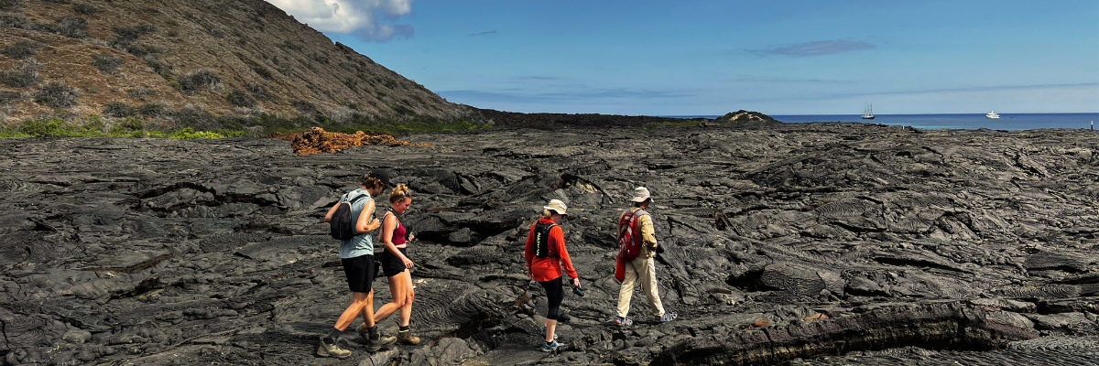
Highlights: Pahoehoe lava, Galapagos penguins, oystercatchers, Galapagos hawks.
Trail | 2,2 km / 1,4 mi
Level | 3
Activities | Dry landing and hiking

PM: BARTOLOME
Bartolome is one of the most iconic places in the Galapagos and one of the few where you can see penguins without going to the remote areas of western Isabela and Fernandina. You will get great views of Pinnacle Rock, located on the northern side of the island, right next to a beautiful peach-color sand beach.
The hike to the top of the island is fantastic and will offer you incredible views of lunar landscapes with scattered volcanic cones. Many islands are visible from this outlook, as well as the bay of Sullivan and the Pinnacle rock.
Snorkel: You will have the option to swim or snorkel from the beach. This area holds a well-deserved reputation of being one of the best snorkeling places in the Galapagos, not only because it’s clear and calm water, but also because of the presence of penguins, which are relatively easy to find while snorkeling, along with an incredible diversity of fish, colorful invertebrates, sea lions, turtles, rays and reef sharks.
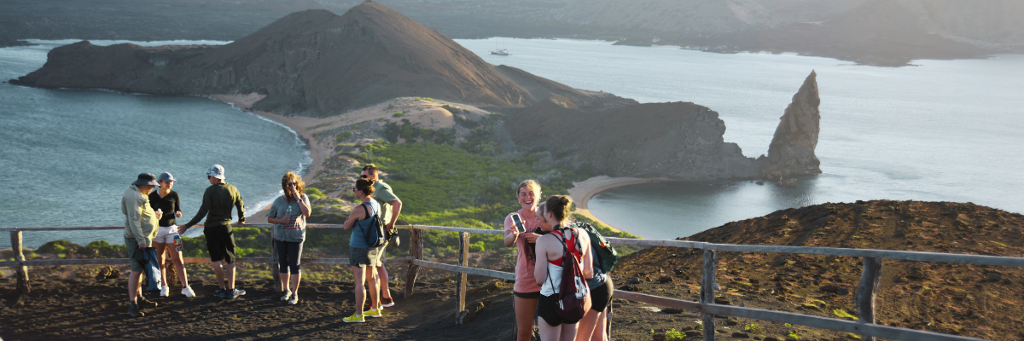
Highlights: Galapagos penguins, volcanic landscapes, Pinnacle rock, blue- footed boobies, herons, sea lions, sharks.
Meals | B / L / D
Trail | 1,5 km / 0,9 mi
Level | 2
Activities | Dry landing and hiking

DAY 5
AM: SEYMOUR
This island is home for large colonies of both magnificent and great frigatebirds and you can see them displaying their red balloons to attract a female. Blue-footed boobies nest in the ground and perform their famous dance in the open areas, while swallow-tailed gulls perch on the cliff edges. Land iguanas are common inland while their marine cousins bask in the rocks by the sea, close to sea lions, which often like to body surf in the waves.
Hiking: This place is a really great location for a walk, as it has tremendous diversity and amount of Galapagos sea lions, blue footed boobies, magnificent & great frigatebirds, land & marine iguanas, swallow-tailed gulls, shearwaters, Darwin finches.
Trail | 1,4 km / 0,8 mi
Meals | B
Level | 1
Activities | Dry landing and hiking

Glossary

Meals | Breakfast | B
 | Lunch | L
 | Dinner | D
Hiking Effort | Level 1 | Easy
 | Level 2 | Moderate
 | Level 3 | Hard

