GALAPAGOS ONBOARD A CRUISE

5 DAYS / 4 NIGHTS CATAMARAN ECOGALAXY
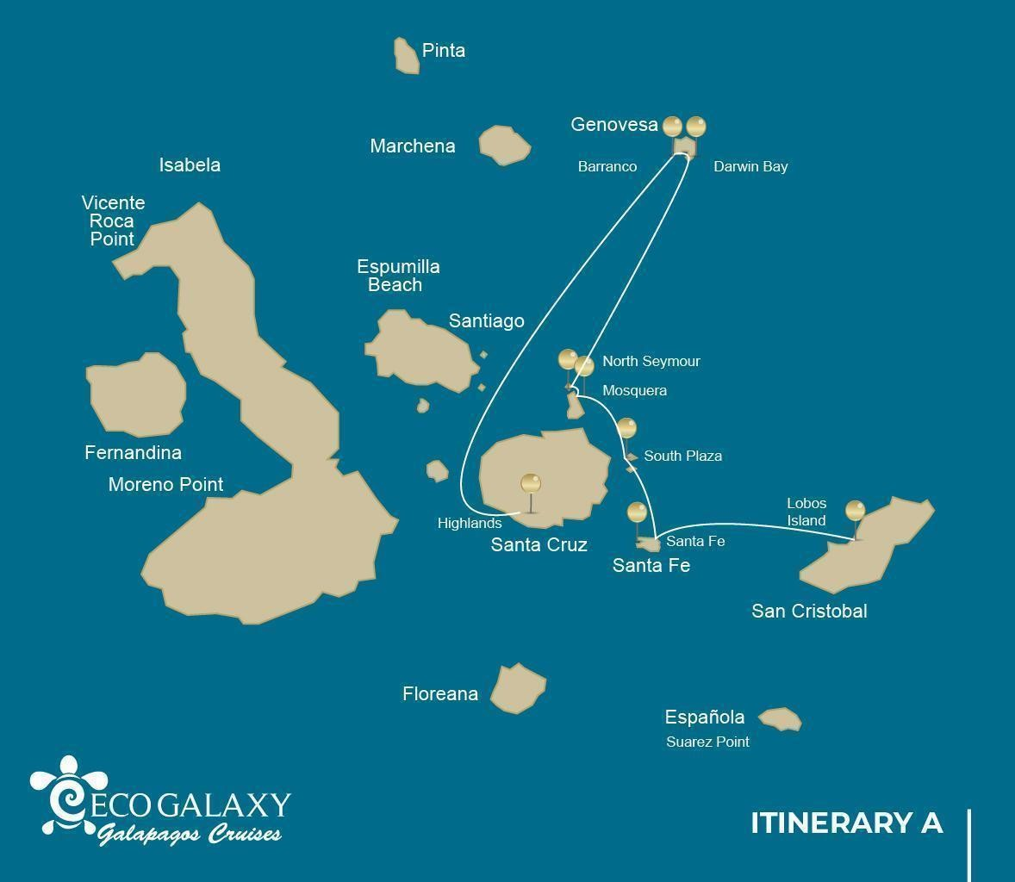

 |  |  |  | HIKING | SNORKEL | PANGA RIDE | PADDLE BOARD | KAYAK
 | TUESDAY | PM | San Cristobal: Lobos Island |  | • | •
5 DAYS | WEDNESDAY | AM | Santa Fe: Santa Fe | • | • | • | • | •
 |  | PM | South Plazas: South Plaza | •
CRUISE  ITINERARY | THURSDAY | AM | Seymour: North Seymour | • | • | •
 |  | PM | Mosquera: Mosquera | • | •
"A"
 |  | AM | Dragon Hill | • | •
 | FRIDAY
 |  | PM | Eden Islet | • | • | •
 | SATURDAY | AM | Santa Cruz: Highland | •

DAY 1- Tuesday / - San Cristobal: Lobos Island AM: ARRIVAL AT SAN CRISTOBAL AIRPORT
Departure to the Galapagos Islands, arrival at San Cristobal airport, where our naturalist guide of the National Park will be waiting for you.
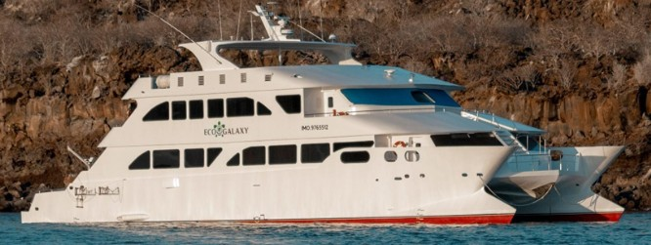

PM: LOBOS ISLAND
Lobos island is a small islet separated from San Cristobal by a narrow channel, forming a sheltered bay where sea lion pups play in tidal pools. A small colony of blue footed boobies, which often nest right on the trail, will give you the opportunity to observe their famous courtship dance.

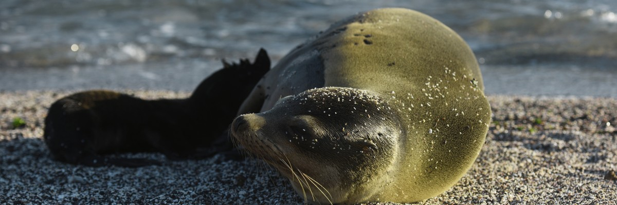

Highlights: Galapagos sea lions, marine Iguanas, magnificent & great frigatebirds, blue-footed Boobies, San Cristobal Lava Lizards.

Meals | L / D
Trail | 0,6 km / 0,4 mi
Level | 3
Activities | Snorkel, Panga Ride

Day 2- Wednesday/ -Santa Fe- South Plaza AM: SANTA FE
Giant Prickly-pear cactus and barren lava rocks surround the landing spot at Santa Fe, located inside one of the most beautiful bays in the Galapagos. Turquoise water and white sand beaches make this location a perfect home for a large colony of sea lions which you will see basking in the sand. Inland, look down for endemic Santa Fe land iguanas, but also look up for Galapagos hawks, which often perch at the top of the cactus looking for prey. Darwin finches, Galapagos doves, mockingbirds and lava lizards are also common along the trail.
Snorkel: After the hike, you will have the option to kayak or snorkel in the sheltered waters inside the bay, where you can swim with sea lion pups and reef sharks. Also look for sea turtles, rays and a large variety of tropical fish including large schools of surgeonfish and parrotfish.
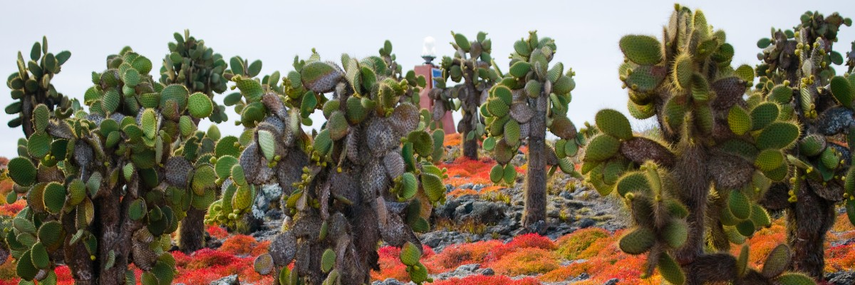

Highlights: Giant cactus, Santa Fe bay, Galapagos sea lions, Santa Fe land iguanas, Galapagos hawks, Galapagos doves, reef sharks.

Trail | 0,8 km / 0,5 mi
Level | 2
Activities | Dry landing and hiking

PM: PLAZAS
Of the two twin islands, only South Plazas is allowed to be visited, while North plazas is kept exclusively for scientific research. This is a small islet, but it packs an impressive amount of wildlife. Right after you land you will see Galapagos land iguanas waiting under prickly-pear cactus feed on their fruits. A large colony of sea lions will give you the opportunity to see playful pups enjoying the tide pools, but also large grumpy males defending their territories. The trail will take you to a cliff where you can observe many sea birds, such as frigatebirds, red-billed tropicbirds, boobies, swallow-tailed gulls and pelicans. A reddish succulent vegetation with scattered cactus covers most of the islands like a carpet, giving this island a unique personality.
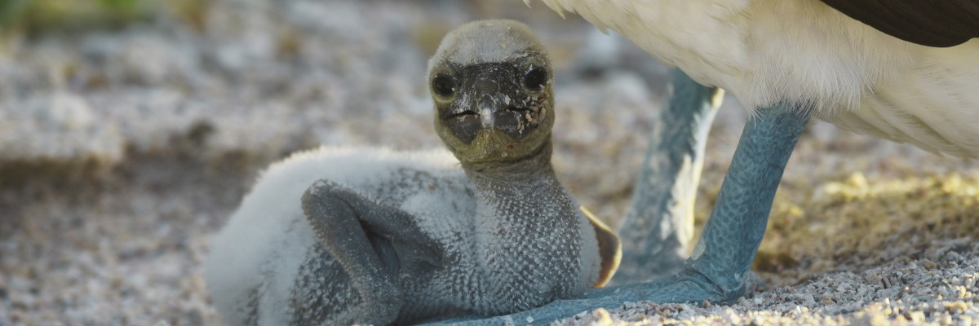

Highlights: Galapagos land iguanas, sea lions, tropicbirds, pelicans, boobies, Galapagos shearwaters, swallow-tailed gulls.

Trail | 1,4 km / 0,8 mi
Level | 2
Meals | B/L/D
Activities | Dry landing and hiking

DAY 3 - THURSDAY/ - North Seymour/ Mosquera AM: SEYMOUR

This island is home for large colonies of both magnificent and great frigatebirds and you can see them displaying their red balloons to attract a female. Blue-footed boobies nest in the ground and perform their famous dance in the open areas, while swallow-tailed gulls perch

on the cliff edges. Land iguanas are common inland while their marine cousins bask in the rocks by the sea, close to sea lions, which often like to body surf in the waves.
Snorkel: This place is a really great snorkeling location, as it has tremendous diversity and amount of fish, but also sea lions, sharks, eels, turtles, rays and many more.
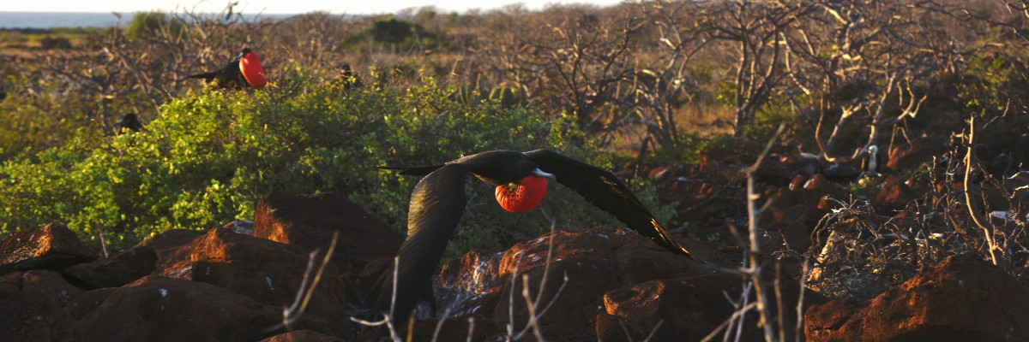

Highlights: Galapagos sea lions, blue footed boobies, magnificent & great frigatebirds, land & marine iguanas, swallow-tailed gulls, shearwaters, Darwin finches.

Trail | 1,4 km / 0,8 mi
Level | 1
Activities | Dry landing and hiking

PM: MOSQUERA

Mosquera is mostly a barren sandbar with some rocky areas and scattered salt-resistant plants. You can walk along the beach and enjoy seeing playful sea lion pups surfing the waves and having a great time in the tide pools. Look for endemic lava gulls which are often seen flying over the beach in the search of food.
Snorkel: If the waves are not too big you can snorkel at the northern tip of the island or at one of the small beaches in the sheltered side.

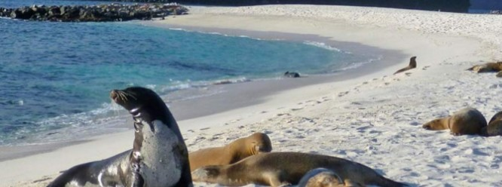

Highlights: Galapagos sea lions, lava gulls, oystercatchers, shorebirds,

Meals | B/L/D
Level | 1
Activities | Wet landing and hiking

DAY 4 -FRIDAY/-
The itinerary of Genovesa, Darwin Bay, and El Barranco, established on this day, has been changed on September 20, 2023, by the Galapagos National Park Directorate (GNPD) due to a Contingency Plan for the Conservation of Species on this island. In its place, visits will be made to the neighboring islands based on the authorization of the Galapagos National Park.

This itinerary will return to normal when the GNPD considers it optimal for the reception of passengers again on Genovesa Island.

AM: DRAGON HILL, THE REBIRTH OF A SPECIES
Located on the northern coast of Santa Cruz, Dragon Hill is aptly named after the land iguanas that make their home in this area. This is the only spot on the entire island of Santa Cruz where you can observe these large reptiles. Thanks to a highly successful breeding program, this land iguana population, which was on the brink of extinction during the '70s and '80s, has bounced back remarkably. Apart from iguanas, flamingos, ducks, stilts, sandpipers, and other shorebirds frequently visit a small saltwater lagoon.

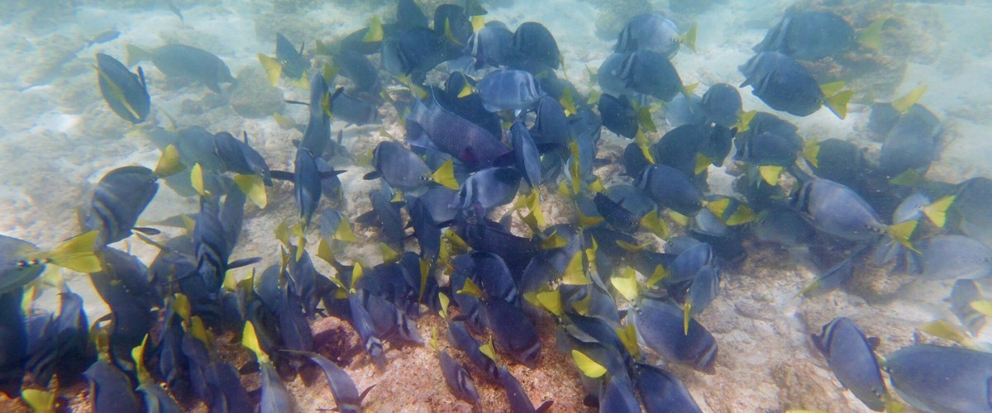

Highlights: Galapagos land iguanas, Darwin finches, American flamingoes, white-cheeked pintails, Galapagos flycatchers, and herons.
As your journey through the Galapagos concludes, you will be transferred to the airport for your return flight to mainland Ecuador. Cherish these unique experiences and memories as you wave goodbye to this stunning ecological marvel. Safe travels!

Meals | B / L / D
Trail | 2,2 km / 1,4 mi

PM: EDEN ISLET
Eden Islet, true to its biblical name, evokes a paradisiacal oasis. Located near Santa Cruz Island, this tiny isle boasts heavenly beaches and crystal-clear waters reminiscent of the quintessential "deserted island." With a diameter of just 600 meters and its highest point reaching 77 meters, its small size is juxtaposed with its immense charm, home to nine turtle species.

Snorkeling Experience: Marvel at the sea stars that cover the ocean floor and the endemic fish, like the white-tailed damselfish, that call it home.

Highlights | Striped burrfish, reef sharks, blue-footed boobies, and Nazca boobies
Meals | Breakfast, Lunch and Dinner
Difficulty | Level 1
Activities | Snorkeling, Panga ride, Kayaking, and Hiking

DAY 5 -SATURDAY / Highland AM: HIGHLANDS

Either if you do this visit starting from Baltra or from Puerto Ayora, a bus will take you to the highlands stopping along the way at one of the reserves to visit the lush highland forests where you will look for Galapagos Giant tortoises in their natural environment. This is the best place in the Galapagos to see these gentle giants (reaching over 300 kg / 600 pounds!) casually grazing and resting in freshwater ponds. This is also home for a great diversity of birds rarely found at the lowlands, including finches (tree, woodpecker and vegetarian finches), flycatchers and several species of water birds. You will visit a lava tunnel (depend on the itinerary) and learn how these extraordinary formations where created by ancient volcanic eruptions.
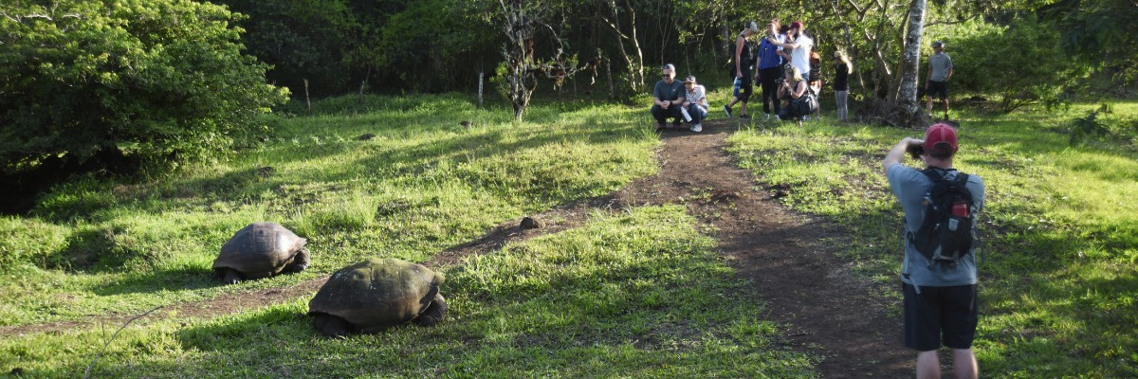

Highlights: Giant tortoises, Darwin finches, barn owls, white-cheeked pintails, Galapagos flycatchers, Lava tunnels.

Meals | B
Trail | 1-1,5 km / 0,6-0,9 mi
Level | 1
Activities | Dry landing and hiking

GLOSSARY
Meals | Breakfast | B
 | Lunch | L
 | Dinner | D
Hiking Effort | Level 1 | Easy
 | Level 2 | Moderate

 | Level 3 | Hard

