Galapagos Express Southeastern Cruise

Itinerary A / 4 days – 3 nights

 |  |  |  | HIKING | SNORKEL | PANGA RIDE | PADDLE BOARD | KAYAK
4 DAYS  “A” | WEDNESDAY | PM | San Cristobal: Lobos Island | • | • | •
 | THURSDAY | AM | Española: Suarez Point | •
 |  | PM | Española: Gardner Bay | • | • | • | •
 | FRIDAY | AM | Floreana: Post Office Bay | • | •
 |  | PM | Floreana: Cormorant Point | • | • | • | • | •
 | SATURDAY | AM | Santa Cruz: Charles Darwin Station | •

Day 1 - Wednesday

AM: EMBARKATION TO THE GALAPAGOS ISLANDS
Unfurl the sails of adventure and embark on an unforgettable journey to the Galapagos Islands. You'll arrive at San Cristobal Airport, where a seasoned naturalist guide, the custodian of this ecological gem, will greet you. Feel the flutter of anticipation as your exploration of this astonishing world heritage site commences.
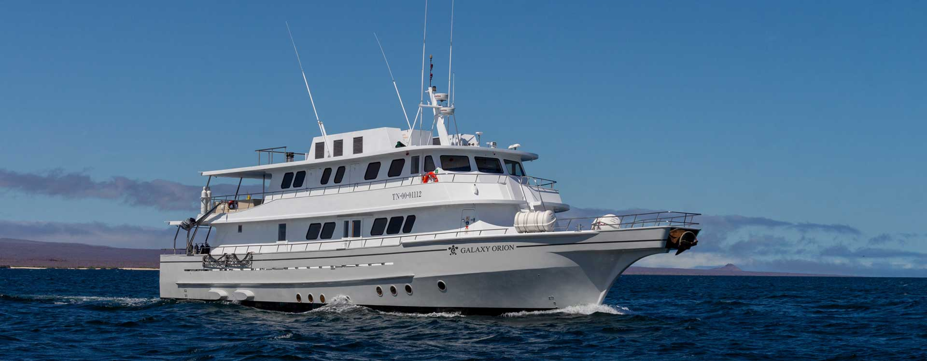
PM: LOBOS ISLAND
Venture to Lobos Island, a tranquil islet secluded from San Cristobal by a slim channel. This nature's cradle, amidst a serene bay, is the playground for sea lion pups frolicking in tidal pools. The island might be modest but bursts with life, particularly with "lobos marinos" or sea lions. As you step ashore, welcoming committees of sea lions would greet you, only to be outraged by the male frigatebirds inland, presenting their inflamed red balloons amidst the verdant foliage. Stay vigilant for the blue-footed boobies nesting on the trails, ready to treat you to a display of their whimsical courtship dance.
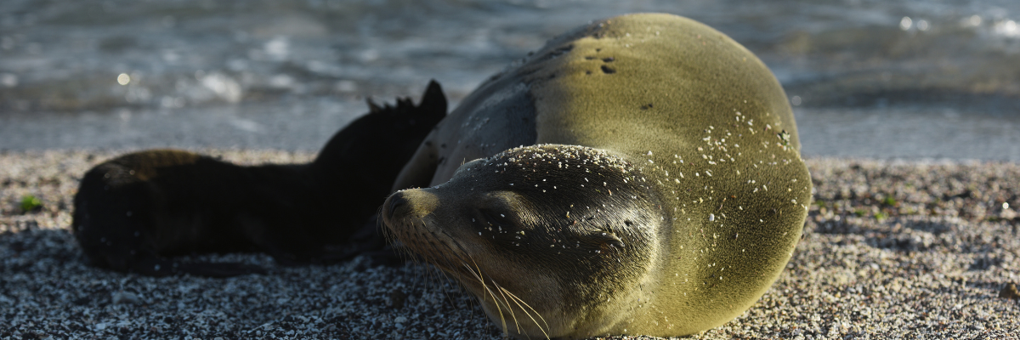
Snorkeling Experience: Dive into an underwater ballet at this renowned snorkeling spot, sheltered by the calm waves. Playful sea lions would eagerly display their acrobatic prowess. In contrast, sea turtles and rays find solace resting on the sandy seabed, giving you a glimpse into the harmonious marine life that thrives beneath the surface.
Highlights: Galapagos sea lions, marine Iguanas, magnificent & great frigatebirds, blue-footed Boobies, and San Cristobal Lava Lizards.
Meals | L, D
Trail | 0,6 km / 0,4 mi
Level | 3
Activities | Dry landing and hiking

Day 2 – Thursday

AM: SUAREZ POINT
Embrace the morning at Suarez Point. This rocky trail presents a natural gallery of the Galapagos islands, brimming with an awe-inspiring array of fauna. Upon landing, you'll be greeted by sea lions and marine iguanas, your first hosts in this nature carnival. As you venture further, you'll encounter a mosaic of seabird colonies - from the striking Nazca and blue-footed boobies to the elegant gulls and tropicbirds. The pinnacle of this journey brings you face-to-face with the waved albatross, the island's largest bird (present from April to January). This majestic creature, exclusive to Española, will captivate you with its powerful flight and intricate courtship display.
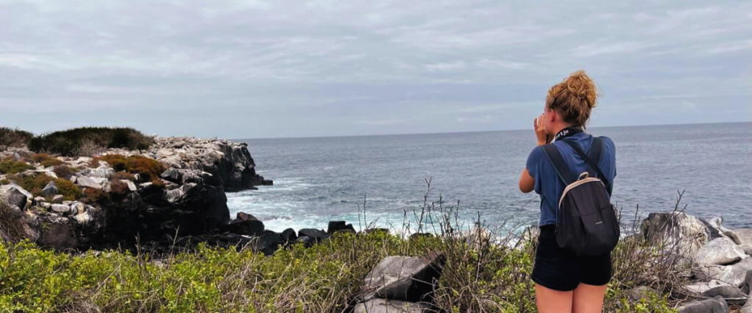
Highlights: Sea lions, Waved Albatross, Galapagos hawks, Española mockingbirds, Darwin finches, marine iguanas, Nazca & Blue-footed Boobies, Red-billed Tropicbirds, Swallow-tailed gulls, herons, lava lizards, herons.
Trail | 1.7 km / 1.1 mi
Level | 3
Activities | Dry landing and hiking

PM: GARDNER BAY
Transition into the afternoon with a thrilling adventure to Gardner Bay, a pristine piece of paradise in the Galapagos archipelago. Sugar-white coral sands merge with crystal-clear turquoise waters, creating a tropical oasis. Watch as the beach becomes a theatre, starring sun-basking sea lions in a playful performance. This idyllic setting invites you to stroll along the coast, immersing yourself in an enlightening experience as you delve into the biology of the endemic fauna - from the melodious Española mockingbird and the unique marine iguanas to the regal Galapagos hawks.
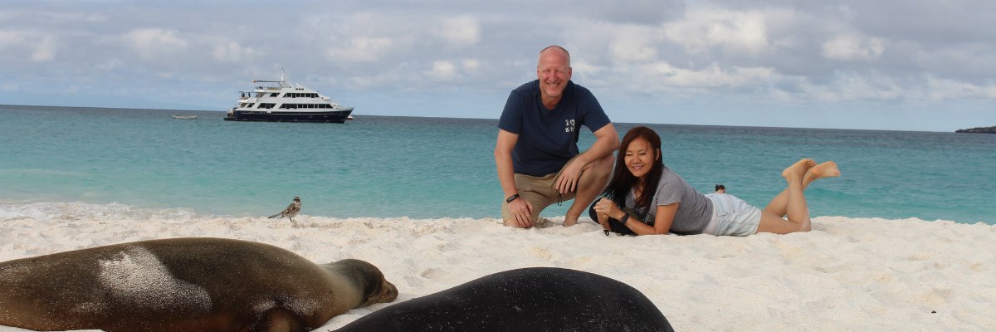
Snorkeling Experience: Submerge beneath the azure waves to witness a spectacular performance choreographed by marine life. Swim alongside playful sea lions, graceful reef sharks, and gliding rays. Discover an array of fish, including vivid Angelfish, charismatic Parrotfish, dynamic Damselfish, and the ever-busy Surgeonfish coloring the underwater landscape.
Highlights: Coral sand beach, sea lions, Galapagos hawks, Española mockingbirds, Darwin finches, marine iguanas.
Meals | B/L/D
Trail | 0,8 km / 0,5 mi
Level | 1
Activities | Wet landing and hiking

Day 3 – Friday

AM: POST OFFICE BAY
Begin your day by stepping into the footprints of the past at Post Office Bay, located on the enigmatic Floreana Island. This locale is imbued with tales from the late 1920s and '30s involving German settlers, a baroness, unsolved mysteries, and captivating intrigue. The bay was a historic anchoring point for whalers, who journeyed to the highlands for freshwater and tortoises. A mail system over two centuries old was established as a hub for visiting vessels centered around a barrel near the beach. This system endures today, offering a unique opportunity to send postcards from this remote part of the world. Apart from its rich history, Post Office Bay presents natural attractions such as a scenic beach, a lava tunnel, and sea tours that can unveil sea lions, green sea turtles, shorebirds, small sharks, and, if luck permits, Galapagos penguins.
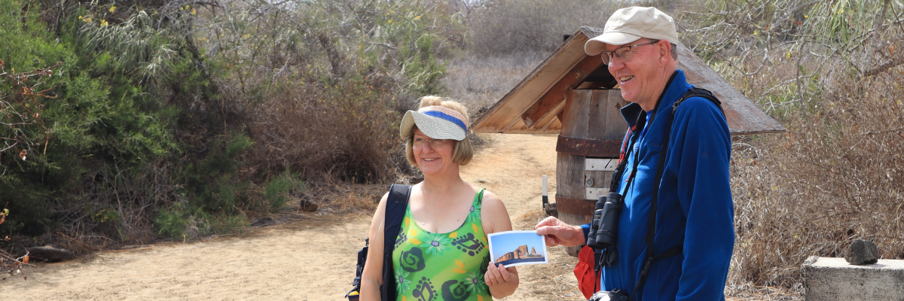
Snorkeling Experience: Delve beneath the waves from the beach, opening up a mesmerizing world of sea turtles, rays, and a diverse plethora of fish. Keep your fingers crossed for a special appearance by the elusive Galapagos penguin.
Highlights: Sea Lions, sea turtles, finches, shorebirds, marine iguanas, and penguins.
Trail | 0,7 km / 0,4 mi
Level | 1
Activities | Wet landing and hiking

PM: CORMORANT POINT
Shift your expedition northwards to Cormorant Point, renowned for its expansive coastal lagoon teeming with American flamingos, white-cheeked pintails, black-necked stilts, and other shorebirds. This natural haven also features a pristine white sand beach, a crucial nesting ground for green sea turtles, and a newly established breeding ground for blue-footed boobies near the trail. Amidst this vibrant wildlife, also take the opportunity to admire the island's unique flora.
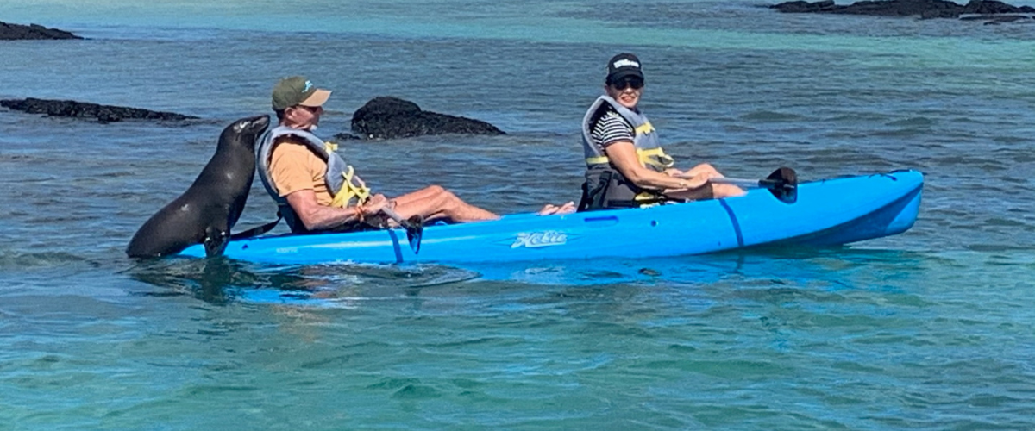
Snorkeling Experience: Snorkeling at Cormorant Point, Floreana, Galapagos, unveils a vibrant underwater world. Visitors swim among tropical fish, rays, sea turtles, and occasionally sea lions beneath crystal-clear waters. The unique olive-green sand beach adds a magical touch to this one-of-a-kind snorkeling experience.
Highlights: American flamingo, blue-footed booby, frigatebirds, tropicbirds, Galapagos shearwaters, sea lions, sea turtle nesting site, finches, shorebirds, coral-sand beach.
Meals | B / L / D
Trail | 1,6 km / 1 mi
Level | 1
Activities | Wet landing and hiking

Day 4 – Saturday

AM: CHARLES DARWIN STATION
Kickstart your day with a profound encounter at the Charles Darwin Station, a dedicated non-profit working hand-in-hand with the Galapagos National Park to safeguard the archipelago's unique biodiversity. This visit provides insights into the collaborative efforts of these institutions to shield native species and combat the invasive ones threatening the delicate balance of the Galapagos ecosystem. One of their emblematic endeavors includes the captive breeding of giant tortoises, an integral part of the conservation strategy. Amidst the educational venture, enjoy the setting of an outdoor native dry forest adorned with towering cacti and a rich array of fascinating endemic flora. This is an ideal spot to discover various endemic Darwin finches, vivacious flycatchers, and melodious mockingbirds.
Highlights: Galapagos giant tortoise & land iguanas breeding program, Darwin finches, Galapagos mockingbirds, Galapagos flycatchers, yellow warblers.
Meals | B
Level | 1
Activities | Dry landing and hiking

Glossary
Meals | Breakfast | B
 | Lunch | L
 | Dinner | D
Hiking Effort | Level 1 | Easy
 | Level 2 | Moderate
 | Level 3 | Hard

