The Unforgettable Journey Among Land Giants and Marine Marvels

6 DAYS / 5 NIGHTS - M/C ALYA

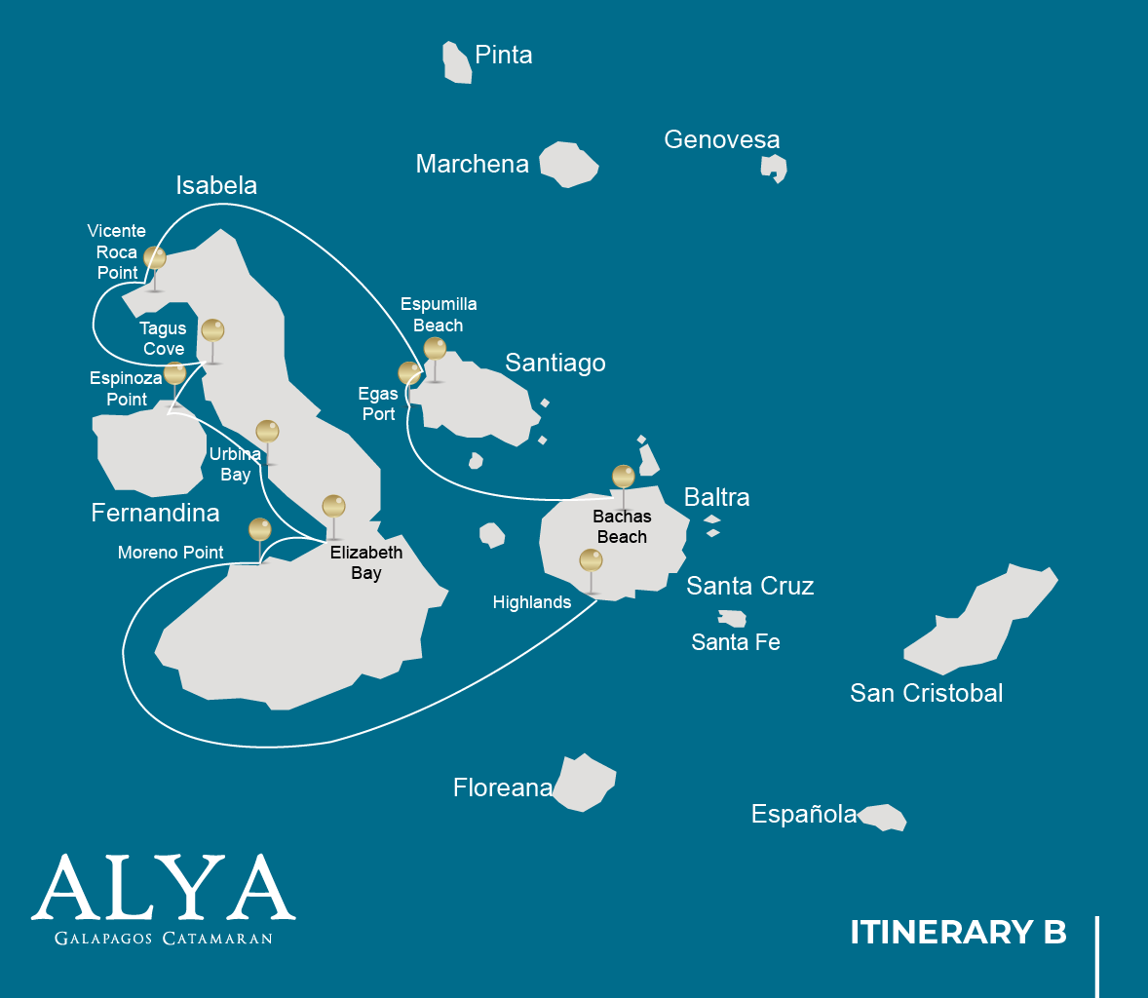

 |  |  |  | HIKING | SNORKEL | PANGA RIDE | PADDLE BOARD | KAYAK
6 DAYS CRUISE “B” | MONDAY | PM | Santa Cruz: Highland | •
 | TUESDAY | AM | Isabela: Moreno Point | • | • | •
 |  | PM | Isabela: Elizabeth Bay |  |  | •
 | WEDNESDAY | AM | Isabela: Urbina Bay | • | •
 |  | PM | Fernandina: Espinoza Point | • | • | •
 | THURSDAY | AM | Isabela: Tagus Cove | • | • | • | • | •
 |  | PM | Isabela: Vicente Roca Point |  | • | •
 | FRIDAY | AM | Santiago: Espumilla Beach | • | • | • | • | •
 |  | PM | Santiago: Egas Port | • | •
 | SATURDAY | AM | Santa Cruz: Bachas | • | •
DAY 1

AM: ARRIVAL AT BALTRA AIRPORT
Your voyage to the captivating Galapagos Islands commences! Upon your arrival at Baltra Airport, you'll be greeted by our National Park-certified naturalist guide, ready to introduce you to the unique wonders of this pristine archipelago.

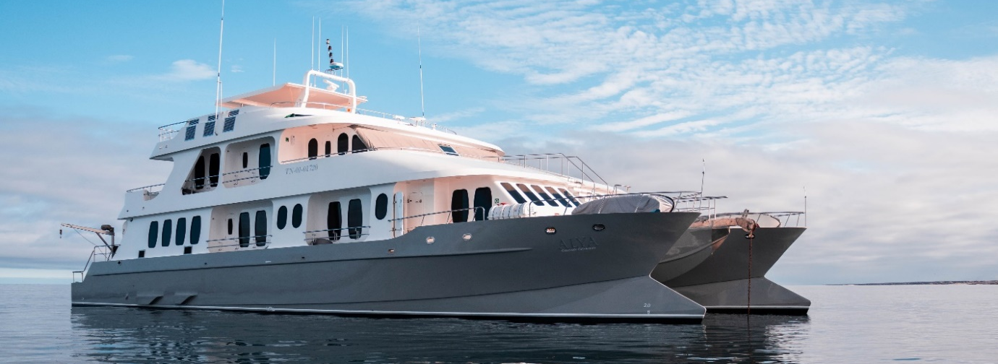

PM: HIGHLANDS
Embark on a highlands adventure, either from Baltra or Puerto Ayora. A bus journey brings you to the verdant highland forests, home to Galapagos Giant tortoises. You'll find these impressive creatures, weighing up to 300 kg/600 lbs, casually grazing or lounging in freshwater ponds. The highlands also host a variety of bird species seldom seen in the lowlands. Depending on your itinerary, explore a lava tunnel and delve into the geological history of these volcanic islands.

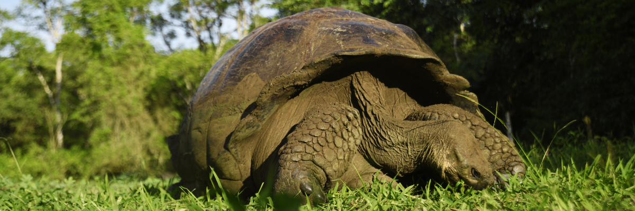

Highlights: Giant tortoises, Darwin finches, barn owls, white-cheeked pintails, Galapagos flycatchers, Lava tunnels.
Meals | L / D
Trail | 1-1,5 km / 0,6-0,9 mi
Level | 1
Activities | Dry landing and hiking

DAY 2

AM: MORENO POINT
Commence your day at the enchanted Moreno Point. The extensive lava fields may first appear lifeless, but within its borders lie scattered brackish lagoons teeming with life such as flamingos, gallinules, ducks, and herons. Along the coast, keep an eye out for penguins, marine iguanas, flightless cormorants, blue-footed boobies, sea lions, oystercatchers, and other shore birds.

Snorkeling Experience: Dip into the refreshing water and explore a mesmerizing underwater world populated by sea turtles, cormorants, and a myriad of fish species. Look carefully within the long seaweeds; you might discover a charming sea horse.

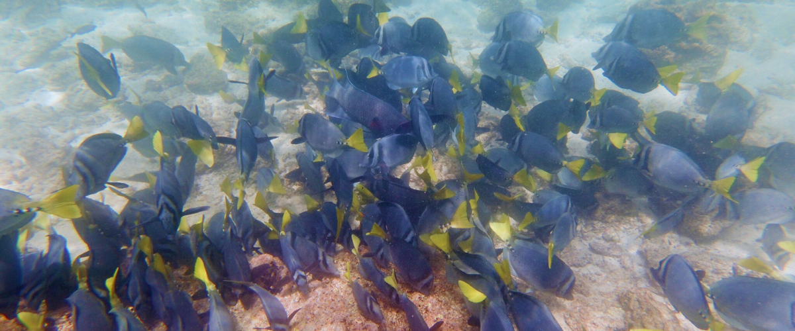

Highlights: American flamingoes, ducks, gallinules, penguins, cormorants, marine iguanas, sea lions, Galapagos mockingbirds, and Darwin finches.

Trail | 1,6 km / 1 mi
Level | 3
Activities | Dry landing and hiking

PM: ELIZABETH BAY
Elizabeth Bay, your afternoon stop, is a sheltered bay encircled by towering mangroves and barren lava fields. There are no trails here, so you'll undertake a dinghy tour to explore the teeming channels, pools, and coves. This location is one of the finest to observe Galapagos penguins, flightless cormorants, blue-footed boobies, pelicans, rays, and sea turtles.

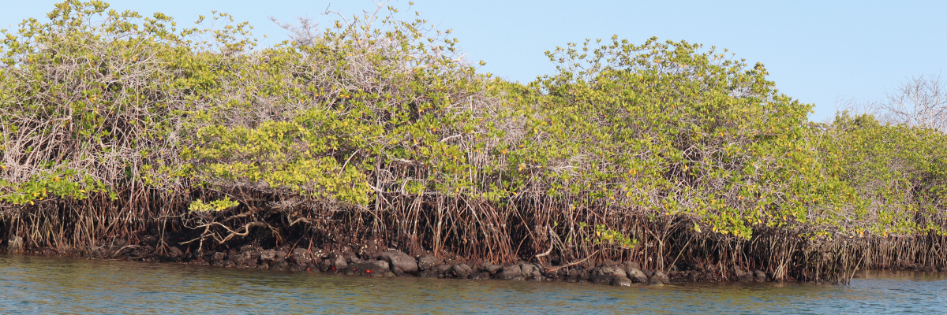

Highlights: Galapagos hawks, sea turtles, rays, Galapagos penguins, flightless cormorants, herons.

Meals | B / L / D
Trail | 1,4 km / 0,8 mi
Level | 1
Activities | Panga Ride

DAY 3

AM: URBINA BAY
Urbina Bay, known for its dramatic uplift during the 1950s, awaits your visit in the morning. As you traverse the trail, observe small shells and corals, indicators that this area was submerged just over sixty years ago. Here you can encounter land iguanas and, during certain seasons, giant tortoises. Galapagos hawks nest in the area, often seen soaring or perched on trees.

Snorkeling Experience: Snorkel from the beach to spot sea turtles, flightless cormorants, and penguins. The area also boasts an abundance of fish.

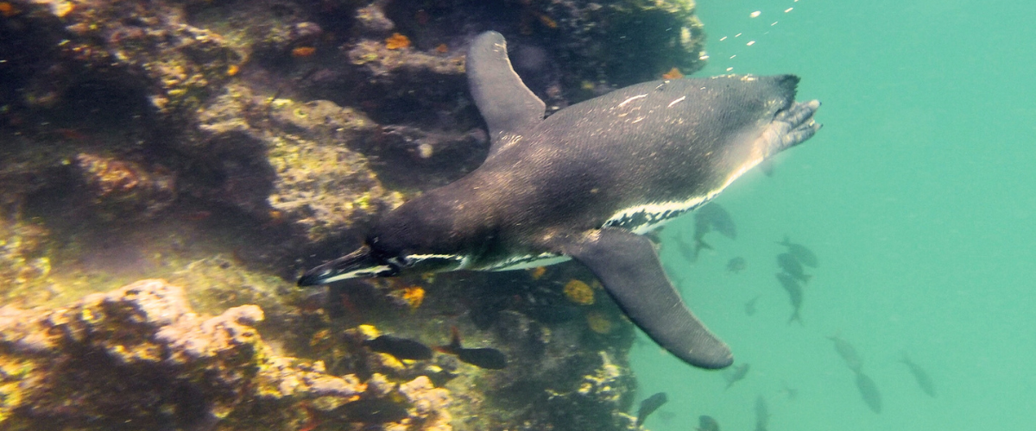

Highlights: Galapagos hawks, land iguanas, Galapagos hawks, Galapagos mockingbirds, Darwin finches, and flycatchers.

Trail | 1,2 km / 0,7 mi. Long Trail: 3,0 km / 1,8 mi
Level | 1
Activities | Wet landing and hiking

PM: ESPINOZA POINT
Espinoza Point is a National Park gem located at the base of an imposing volcano (the most active in the Galapagos islands). Upon landing, be greeted by hundreds of marine iguanas in the largest colony for the species. Also present are sea lions, flightless cormorants, herons, pelicans, oystercatchers, sea turtles, shorebirds, and more. Look to the mangroves where Galapagos hawks often perch, on the lookout for prey.

Snorkeling Experience: Immerse yourself in the nutrient-rich waters around Espinoza Point, brimming with a plethora of fish and sea turtles. Witness marine iguanas feeding underwater amidst a cornucopia of seaweeds.

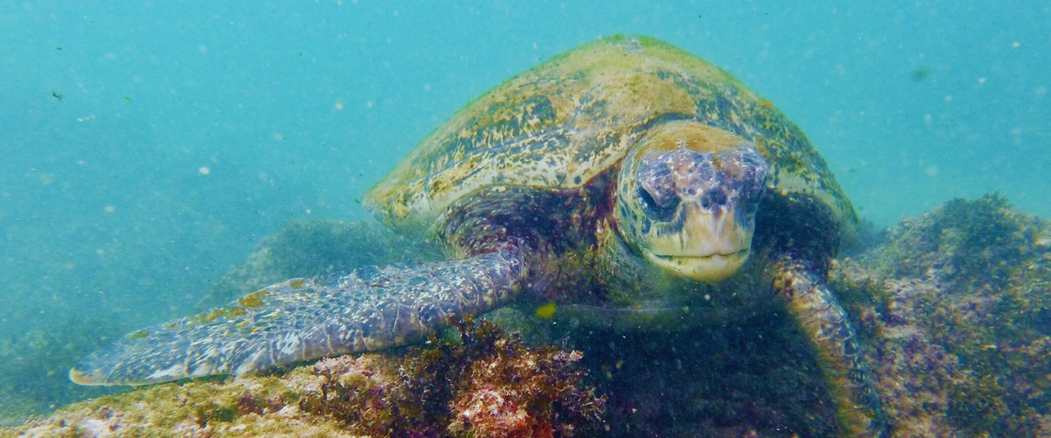

Highlights: Galapagos hawks, marine iguanas, flightless cormorants, penguins, sea turtles, sea lions, herons, oystercatchers, shorebirds, and Sally light-foot crabs.

Meals | B / L / D
Trail | 1,6 km / 1 mi
Level | 2
Activities | Dry landing and hiking

DAY 4

AM: TAGUS COVE
Tagus Cove, a location visited by Charles Darwin during his Galapagos exploration, offers a dry Palo Santo forest where Darwin finches and mockingbirds reside. Take in the marvelous views of Darwin's Lake and the grand volcanos of northern Isabela. A boat tour along the coast will reveal penguins, cormorants, marine iguanas, and the Galapagos martin, an endangered endemic species.

Snorkeling Experience: Dive into the nutrient-rich waters around Tagus Cove, where many sea turtles, a great diversity of fish, and penguins await, feasting on large schools of anchovies. Cormorants are commonly spotted underwater as they chase fish through the reef.

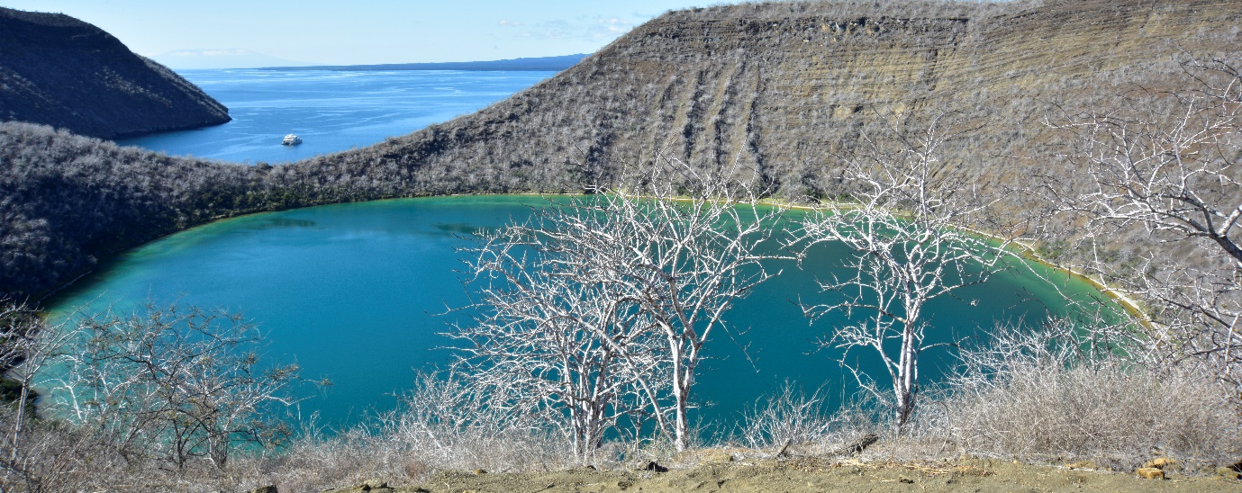

Highlights: Galapagos hawks, marine iguanas, flightless cormorants, herons, penguins, sea turtles, and sea stars.

Trail | 2,6 km / 1,6 mi
Level | 3
Activities | Dry landing and hiking

PM: VICENTE ROCA POINT
Vicente Roca Point, surrounded by some of the tallest cliffs in the Galapagos, is ideal for observing breathtaking landscapes and interesting volcanic features. A dinghy tour will offer closer views of pelicans, flightless cormorants, sea turtles, boobies, Galapagos fur seals, and marine iguanas. Whales and dolphins also frequent the area.

Snorkeling Experience: Venture beneath the waves to see sea turtles, penguins, sea lions, cormorants, rays, and many different fish species. Watch for fan corals, sponges, and other invertebrates growing on the walls.

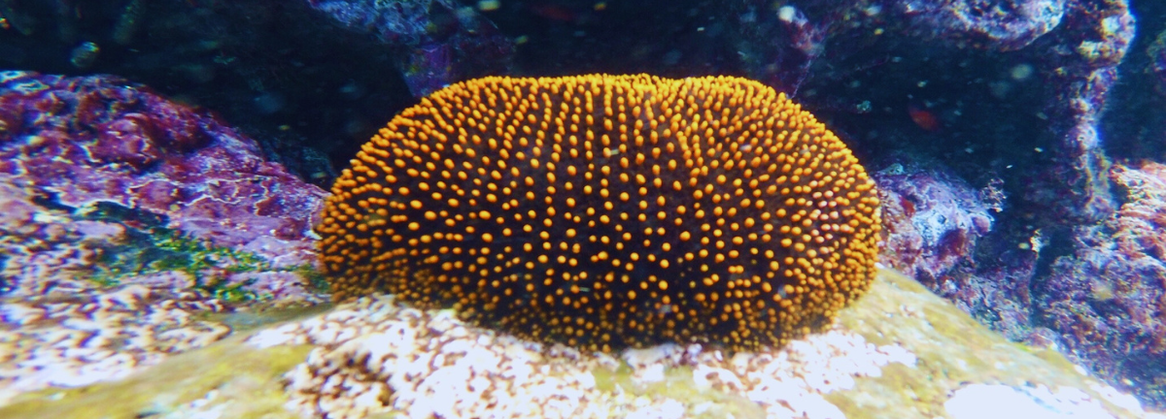

Highlights: Marine iguanas, flightless cormorants, penguins, sea turtles, fur seals, Nazca & blue-footed boobies

Meals | B / L / D
Trail | 1,4 km / 0,8 mi
Level | 1
Activities | Panga ride

DAY 5

AM: ESPUMILLA BEACH
Begin your day at the picturesque Espumilla Beach, a long stretch of rusty-brown sand nestled on Santiago's northern coast. Surrounded by large mangrove trees and a captivating native dry forest, the area hosts Galapagos hawks and an array of finches, mockingbirds, and doves. During the rainy season, don't miss the chance to spot flamingoes and ducks in the salt pan.

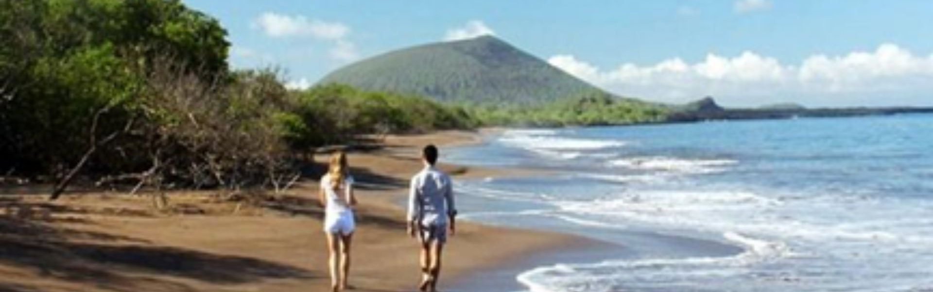

Highlights: Bobbies, oystercatchers, herons, Galapagos mockingbirds, Darwin finches, Galapagos hawks.

Trail | 2,3 km / 1,4 mi (plus an extra loop 1 km - 0,6 mi)
Level | 1
Activities | Wet landing and hiking

PM: EGAS PORT
Despite its name, there's no port at Puerto Egas, but remnants from the 60s colonization attempts still linger. The trail along the wildlife-rich coastline leads to "the grottos," home to a small colony of the endemic Galapagos fur seal. In 2019, land iguanas were reintroduced, so keep your eyes peeled for these fascinating reptiles.

Snorkeling Experience: Snorkel from the beach to explore rocky bottoms teeming with fish, turtles, and reef sharks. Sea lions often join in, happy to interact with divers.

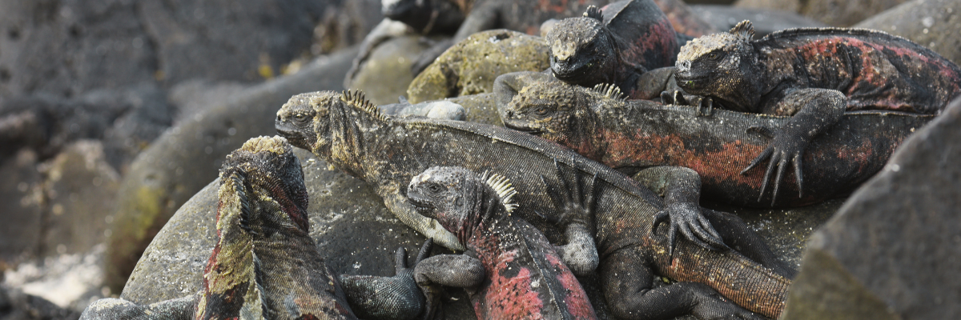

Highlights: Galapagos sea lions, Galapagos fur seals, oystercatchers, marine & land iguanas, Galapagos hawks, herons, shorebirds, Darwin finches, Galapagos doves.

Meals | B / L / D
Level | 1
Trail | 2,3 km / 1,4 mi
Activities | Wet landing and hiking

DAY 6

AM: BACHAS
Bachas, named after the mispronounced "barges" left by the Americans during WWII, begins your final day. At low tide, the iron skeletons of the barges can still be spotted buried in the white sand. This spot is one of the most crucial sea turtle nesting grounds in the Galapagos islands from November to May. Several small saltwater lagoons are often home to flamingoes, herons, and other aquatic birds.

Following your visit to Bachas, you will be transferred to the airport for your flight back to mainland Ecuador, concluding your unforgettable Galapagos journey.

Highlights: American flamingoes, white-cheeked pintails, sandpipers, lava gulls, and blue-footed boobies.

Meals | B
Trail | 1,6 km / 1 mi
Level | 1
Activities | Wet landing and hiking

Glossary

Meals | Breakfast | B
 | Lunch | L
 | Dinner | D
Hiking Effort | Level 1 | Easy
 | Level 2 | Moderate
 | Level 3 | Hard

