Galapagos Western Hidden Jewels Cruise

Itinerary B / 8 days – 7 nights

 |  |  |  | HIKING | SNORKEL | PANGA RIDE | PADDLE BOARD | KAYAK
8 DAYS  “B” | SATURDAY | PM | Santa Cruz: Highlands | • | •
 | SUNDAY | AM | Isabela: Tintoreras | • |  | •
 |  | PM | Isabela: Wetlands & Interpretation Center | • | • | • | •
 | MONDAY | AM | Isabela: Moreno Point | • | •
 |  | PM | Isabela: Elizabeth Bay | • | • | • | • | •
 | TUESDAY | AM | Fernandina: Mangle Point | • | • | •
 |  | PM | Isabela: Urbina Bay | • | •
 | WEDNESDAY | AM | Isabela: Tagus Cove | • | • | • | • | •
 |  | PM | Fernandina: Espinoza Point | • | • | •
 | THURSDAY | AM | Santiago: Egas Point | • | •
 |  | PM | Santiago: Espumilla Beach & Bucaneer Cove | • | • | • | • | •
 | FRIDAY | AM | Genovesa: El Barranco | • | • | • | • | •
 |  | PM | Genovesa: Darwin Bay | • | • | • | • | •
 | SATURDAY | AM | Seymour: North Seymour | •

Day 1 - Saturday

AM: ARRIVAL AT BALTRA AIRPORT
Your voyage to the captivating Galapagos Islands commences! Upon your arrival at Baltra Airport, you'll be greeted by our National Park-certified naturalist guide, ready to introduce you to the unique wonders of this pristine archipelago.
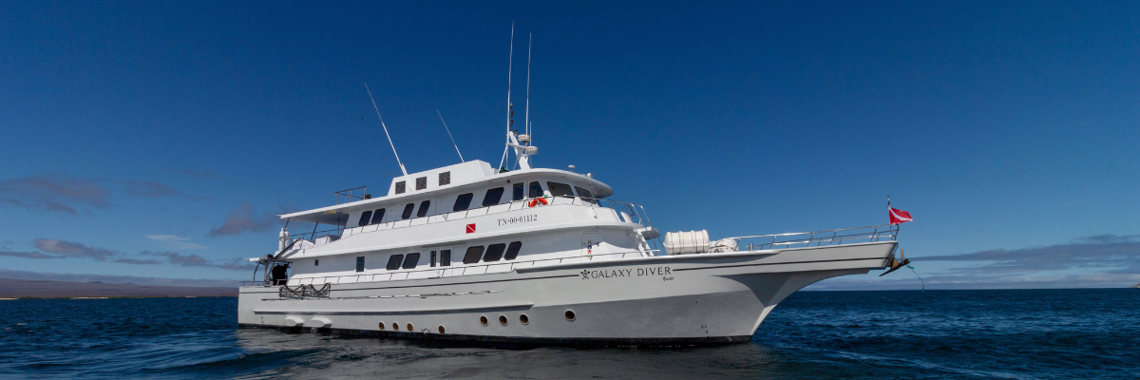

PM: HIGHLANDS
Embark on a highlands adventure, either from Baltra or Puerto Ayora. A bus journey brings you to the verdant highland forests, home to Galapagos Giant tortoises. You'll find these impressive creatures, weighing up to 300 kg/600 lbs, casually grazing or lounging in freshwater ponds. The highlands also host a variety of bird species seldom seen in the lowlands. Depending on your itinerary, explore a lava tunnel and delve into the geological history of these volcanic islands.

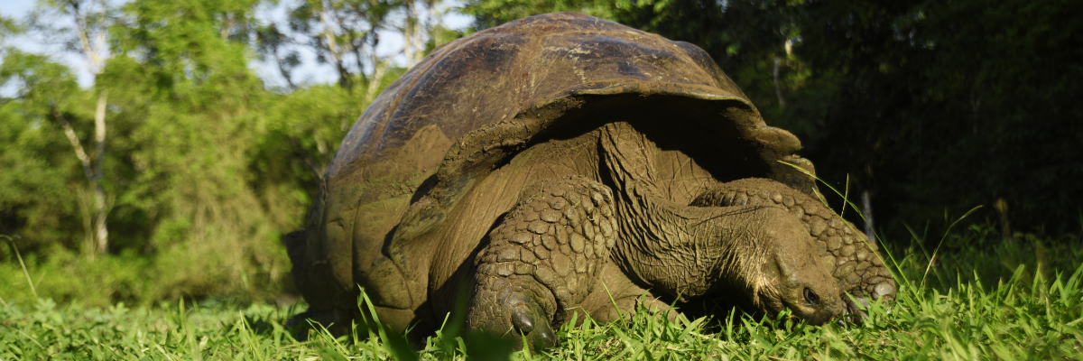
Highlights: Giant tortoises, Darwin finches, barn owls, white-cheeked pintails, Galapagos flycatchers, Lava tunnels.

Meals | L / D
Trail | 1-1.5 km / 0.6-0.9 mi
Level | 1
Activities | Dry landing and hiking

Day 2 – Sunday

AM: TINTORERAS & SIERRA NEGRA VOLCANO
Start your morning on Isabela Island, embarking on a unique adventure at Tintoreras, a cluster of small isles teeming with wildlife. Sail through crystal-clear waters and discover a vibrant underwater world inhabited by white-tipped sharks, colorful tropical fish, and starfish. Continue excursing to Sierra Negra Volcano, one of the world's largest and most active craters. The hike will take you through lunar landscapes and breathtaking views, where you’ll learn about volcanic geology and the endemic flora and fauna.
Snorkeling: Dive into the marvelous marine world of Isabela. Swim alongside sea turtles, manta rays, and, if you’re lucky, Galapagos penguins.
Highlights: Tintoreras, Sierra Negra Volcano, white-tipped sharks, sea turtles, manta rays.

Trail | 6 km / 3.7 mi
Level | 2
Activities | Wet landing, hiking, snorkeling

PM: ISABELA ISLAND WETLANDS & INTERPRETATION CENTER
In the afternoon, explore the wetlands of Isabela Island, a vital ecosystem for the biodiversity of the Galapagos. These trails take you through mangroves, saline lagoons, and beaches, where you can spot flamingos, blue-billed ducks, and other aquatic birds. Conclude the day at the Interpretation Center, discovering the natural and human history of the islands, their conservation, and the ongoing efforts to protect this World Heritage Site.
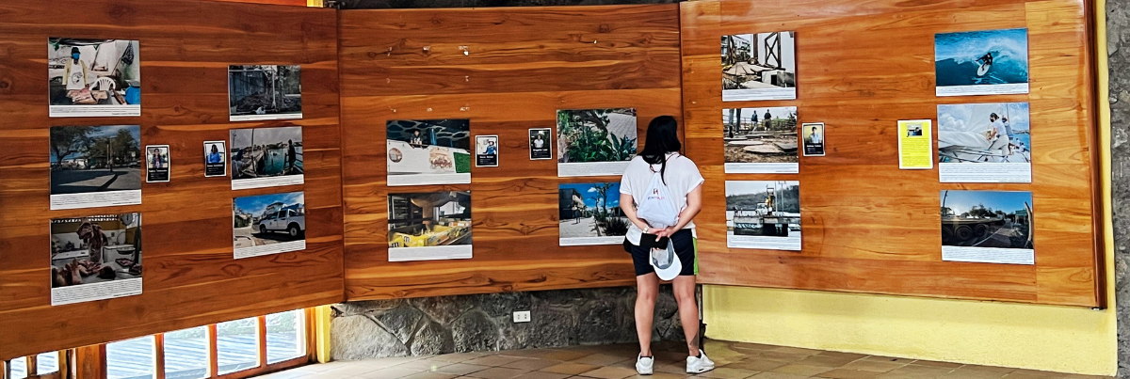
Highlights: Wetlands, mangroves, flamingos, blue-billed ducks, Interpretation Center.
Meals | B / L / D
Trail | 3 km / 1.86 mi
Level | 1
Activities | Hiking

Day 3 – Monday

AM: MORENO POINT
Commence your day at the enchanted Moreno Point. The extensive lava fields may appear lifeless, but scattered brackish lagoons teeming with life, such as flamingos, gallinules, ducks, and herons lie within its borders. Along the coast, keep an eye out for penguins, marine iguanas, flightless cormorants, blue-footed boobies, sea lions, oystercatchers, and other shore birds.
Snorkeling Experience: Dip into the refreshing water and explore a mesmerizing underwater world populated by sea turtles, cormorants, and a myriad of fish species. Look carefully within the long seaweeds; you might discover a charming sea horse.
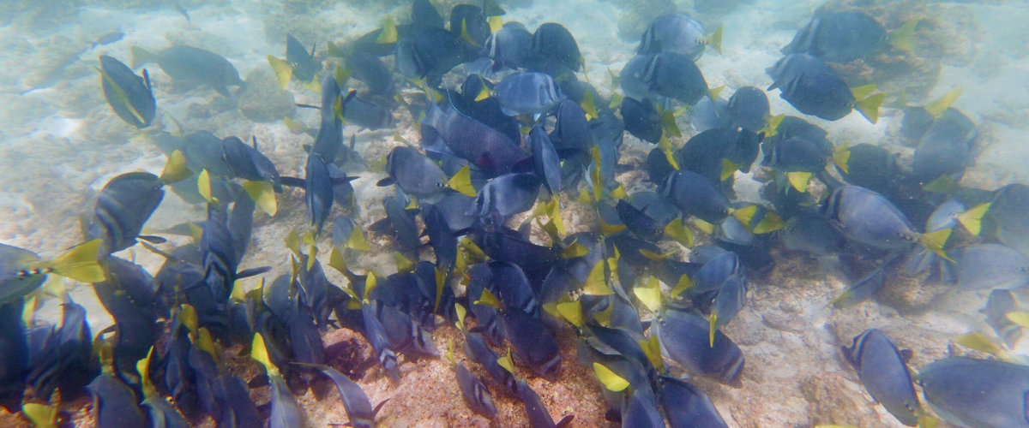

Highlights: American flamingoes, ducks, gallinules, penguins, cormorants, marine iguanas, sea lions, Galapagos mockingbirds, and Darwin finches.
Trail | 1.6 km / 1 mi
Level | 3
Activities | Dry landing and hiking

PM: ELIZABETH BAY
Elizabeth Bay, your afternoon stop, is a sheltered bay encircled by towering mangroves and barren lava fields. There are no trails here, so you'll undertake a dinghy tour to explore the teeming channels, pools, and coves. This location is one of the finest to observe Galapagos penguins, flightless cormorants, blue-footed boobies, pelicans, rays, and sea turtles.
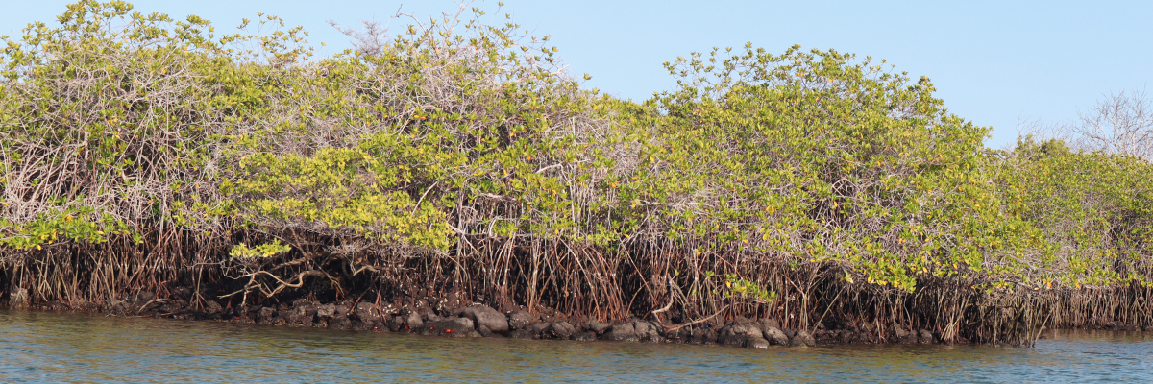
Highlights: Galapagos hawks, sea turtles, rays, Galapagos penguins, flightless cormorants, and herons.
Meals | B / L / D
Trail | 1,4 km / 0,8 mi
Level | 1
Activities | Panga Ride

Day 4 – Tuesday

AM: MANGLE POINT
Begin your day at Mangle Point on the pristine Fernandina Island, one of the Galapagos's most untouched and ecologically pure islands. This location offers a spectacular mangrove ecosystem, a haven for wildlife. As your boat gently navigates through the clear waters, observe the intricate mangrove roots where marine turtles and rays often hide. The calm and shallow waters make this an ideal spot for snorkeling, offering a chance to swim alongside sea turtles, various species of rays, and abundant tropical fish.
Mangle Point presents a unique opportunity to witness the symbiosis between the mangrove forests and the marine environment, offering a serene and intimate experience with nature.
Snorkeling Experience: Immerse yourself in the tranquil waters of Mangle Point—experience close encounters with the diverse marine life that thrives among the mangroves and coral reefs.
Highlights: Mangrove ecosystem, sea turtles, rays, tropical fish.
Trail | N/A (mainly a water-based activity)
Level | 1
Activities | Panga (dinghy) ride, snorkeling

PM: URBINA BAY
Urbina Bay, known for its dramatic uplift during the 1950s, awaits your visit in the morning. As you traverse the trail, observe small shells and corals, indicators that this area was submerged just over sixty years ago. Here, you can encounter land iguanas and, during certain seasons, giant tortoises. Galapagos hawks nest in the area, often seen soaring or perched on trees.
Snorkeling Experience: Snorkel from the beach to spot sea turtles, flightless cormorants, and penguins. The area also boasts an abundance of fish.
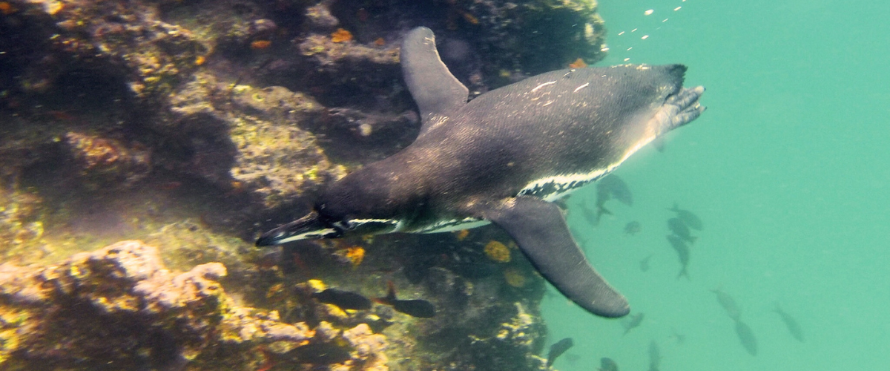
Highlights: Galapagos hawks, land iguanas, Galapagos hawks, Galapagos mockingbirds, Darwin finches, and flycatchers.
Meals | B / L / D
Trail | Short trail: 1,2 km / 0,7 mi. Long Trail: 3,0 km / 1,8 mi
Level | 1
Activities | Wet landing and hiking

Day 5 – Wednesday

AM: TAGUS COVE
Tagus Cove, a location visited by Charles Darwin during his Galapagos exploration, offers a dry Palo Santo forest where Darwin finches and mockingbirds reside. Take in the marvelous views of Darwin's Lake and the grand volcanos of northern Isabela. A boat tour along the coast will reveal penguins, cormorants, marine iguanas, and the Galapagos martin, an endangered endemic species.
Snorkeling Experience: Dive into the nutrient-rich waters around Tagus Cove, where many sea turtles, a great diversity of fish, and penguins await, feasting on large schools of anchovies. Cormorants are commonly spotted underwater as they chase fish through the reef.
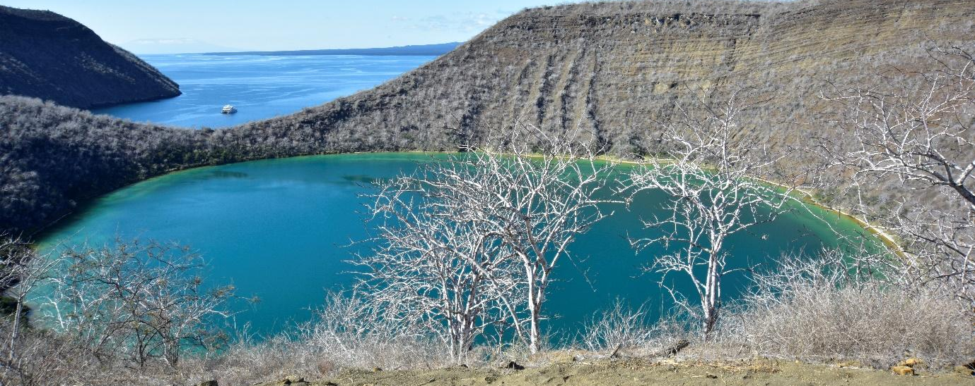
Highlights: Galapagos hawks, marine iguanas, flightless cormorants, herons, penguins, sea turtles, and sea stars.
Trail | 2.6 km / 1.6 mi
Level | 3
Activities | Dry landing and hiking

PM: ESPINOZA POINT
Espinoza Point is a National Park gem located at the base of an imposing volcano (the most active in the Galapagos islands). Upon landing, be greeted by hundreds of marine iguanas in the largest colony for the species. Also present are sea lions, flightless cormorants, herons, pelicans, oystercatchers, sea turtles, shorebirds, and more. Look to the mangroves where Galapagos hawks often perch, on the lookout for prey.

Snorkeling Experience: Immerse yourself in the nutrient-rich waters around Espinoza Point, brimming with a plethora of fish and sea turtles. Witness marine iguanas feeding underwater amidst a cornucopia of seaweeds.
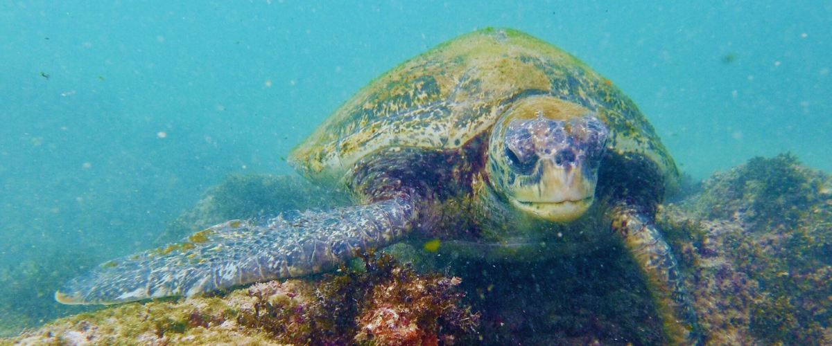
Highlights: Galapagos hawks, marine iguanas, flightless cormorants, penguins, sea turtles, sea lions, herons, oystercatchers, shorebirds, and Sally light-foot crabs.
Meals | B / L / D
Trail | 1.6 km / 1 mi
Level | 2
Activities | Dry landing and hiking

Day 6 – Thursday

AM: EGAS POINT
Despite its name, there's no port at Puerto Egas, but remnants from the 60s colonization attempts still linger. The trail along the wildlife-rich coastline leads to "the grottos," home to a small colony of the endemic Galapagos fur seal. In 2019, land iguanas were reintroduced, so keep your eyes peeled for these fascinating reptiles.
Snorkeling Experience: Snorkel from the beach to explore rocky bottoms teeming with fish, turtles, and reef sharks. Sea lions often join in, happy to interact with divers.

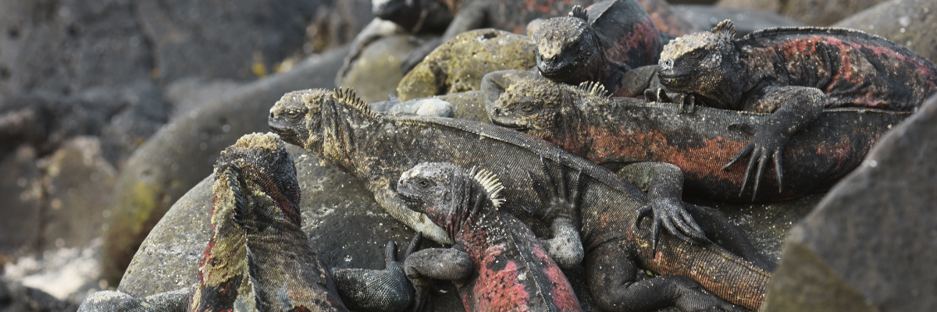
Highlights: Galapagos sea lions, Galapagos fur seals, oystercatchers, marine & land iguanas, Galapagos hawks, herons, shorebirds, Darwin finches, Galapagos doves.
Level | 1
Trail | 2.3 km / 1.4 mi
Activities | Wet landing and hiking

PM: ESPUMILLA BEACH & BUCANEER COVE
Start your morning at Espumilla Beach on Santiago Island, a location famous for its stunning, golden sandy beach and mangrove forest. The beach is a nesting site for sea turtles and is also known for its excellent swimming and snorkeling opportunities. The calm waters and diverse marine life, including octopuses, moray eels, and reef sharks, make for an unforgettable snorkeling experience. Following the beach, visit Buccaneer Cove, a historic area frequented by pirates and whalers in the past. This cove is surrounded by high cliffs and tuff formations, creating a breathtaking natural amphitheater. It's a great place for spotting seabirds like pelicans, boobies, and seagulls.
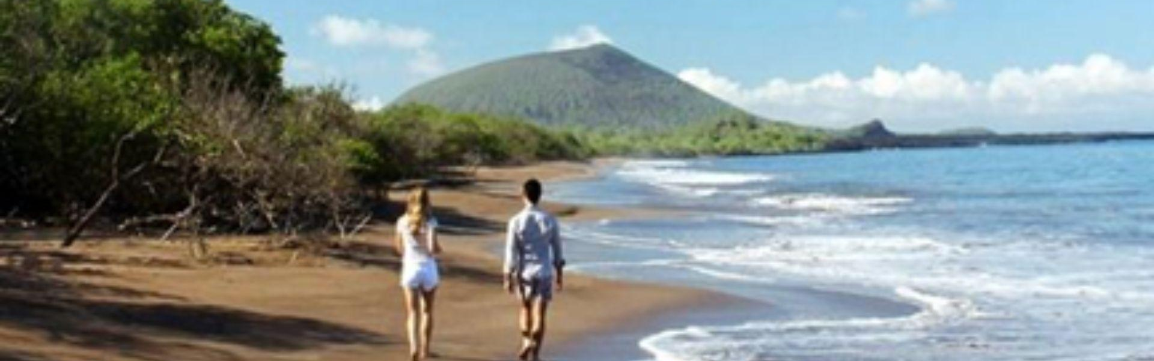
This combination of natural beauty and history provides a multifaceted experience, allowing you to enjoy both the tranquil beach setting and the adventurous tales of Buccaneer Cove
Snorkeling Experience: Enjoy the clear waters at Espumilla Beach and the rich historical backdrop of Buccaneer Cove. Discover the underwater world and the area’s intriguing history.
Highlights: Bobbies, oystercatchers, herons, Galapagos mockingbirds, Darwin finches, Galapagos hawks, sea turtles, snorkeling, historical pirate and whaler site.
Meals | B / L / D
Trail | 1.5 km (plus an extra loop 1 km) / (0.9 – 0.6 mi)
Level | 2
Activities | Wet landing, snorkeling, panga (dinghy) ride along the cove

Day 7 – Friday

AM: EL BARRANCO
Next stop, El Barranco. Known for its fractured lava cliffs serving as the perfect dwelling for storm petrel colonies, this unique ecosystem draws a significant population of short-eared owls. A trail alongside these cliffs reveals red-footed and Nazca boobies aplenty. Resting in the shadows at the cliffs' base, you may spot Galapagos fur seals and numerous seabirds.
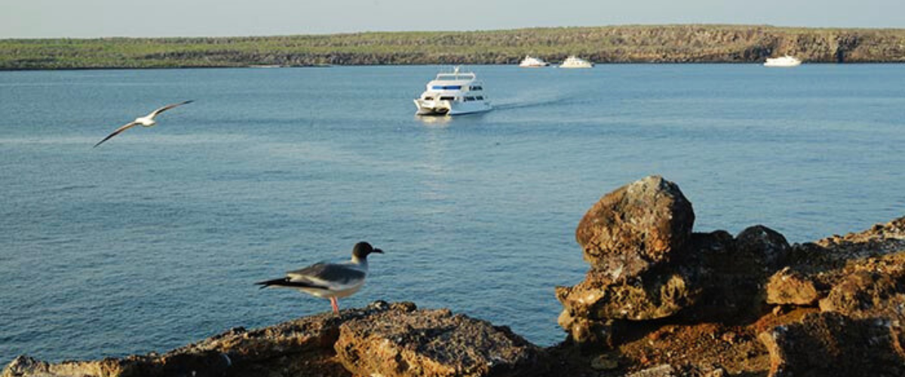
Snorkeling Experience: The deep blue waters along the cliffs offer another underwater escapade with a profusion of colorful fish, sharks, rays, and sea lions.
Highlights: Nesting great frigatebirds, red-footed & Nazca boobies, Galapagos sea lions, Galapagos fur seals, lava & swallow-tailed gulls, yellow-crown night herons, Genovesa ground finch, Genovesa cactus finch, Galapagos mockingbirds.
Trail | 1,2 km / 0,7 mi
Level | 3
Activities | Dry landing and hiking

PM: DARWIN BAY
Start your day surrounded by the bustling avian life of Darwin Bay on Genovesa Island, a birdwatcher's paradise. As soon as your feet touch the sandy terrain, you're welcomed by a symphony of seabird calls, with frigatebirds, boobies, and gulls soaring overhead or nestled in the foliage. The trail meanders through colonies of sea lions, marine iguanas, night herons, Darwin finches, Galapagos doves, mockingbirds, and more.
Snorkeling Experience: Dive into the bay's underwater realms, teeming with vibrant fish, elusive sharks, graceful rays, and playful sea lions. With multiple snorkeling spots, from cliff-lined deep waters to shallow beachside areas, you're guaranteed a spectacular aquatic show.
Highlights: Nesting great frigatebirds, red-footed & Nazca boobies, Galapagos sea lions, lava & swallow-tailed gulls, yellow-crowned night herons, Genovesa ground finch, Genovesa cactus finch, Galapagos mockingbirds.
Trail | 1,2 km / 0,7 mi
Level | 3
Activities | Wet landing and hiking

Day 8 – Saturday

AM – NORTH SEYMOUR & TRANSFER OUT TO BALTRA’S AIRPORT
Your journey continues with a morning visit to North Seymour Island, a spectacular showcase of the Galapagos Islands' diverse wildlife. This relatively flat island is home to a thriving population of blue-footed boobies and frigate birds. The trail winds its way through a forest of low, bushy vegetation, where you'll have the opportunity to witness the fascinating courtship dance of the blue-footed boobies. The island's coastline also allows one to observe sea lions and marine iguanas basking in the sun. The large frigate bird colonies are a sight, especially when the males inflate their bright red throat pouches to attract mates.
Birdwatching Experience: Encounter the majestic frigate birds and charming blue-footed boobies in their natural habitat. This is an ideal spot for birdwatching and photography.
Highlights: Blue-footed boobies, frigate birds, sea lions, marine iguanas.
Trail | 2 km
Level | 2
Activities | Dry landing, hiking

As the day winds down, prepare for your return to the Ecuador mainland. Reflect on the extraordinary experiences and memories created as you journey back. The return trip is a time to relax and ponder the unique ecosystems and incredible wildlife you've encountered, leaving the enchanted islands behind but taking a piece of their magic.
This concludes your remarkable journey through the Galapagos, filled with awe-inspiring encounters with nature's wonders, leaving you with a deeper appreciation for the delicate balance of our planet's ecosystems.

Glossary

Meals | Breakfast | B | Hiking Effort | Level 1 | Easy
 | Lunch | L |  | Level 2 | Moderate
 | Dinner | D |  | Level 3 | Hard

