Galapagos Central Wonders Cruise

Itinerary C / 5 days – 4 nights

 |  |  |  | HIKING | SNORKEL | PANGA RIDE | PADDLE BOARD | KAYAK
5 DAYS  “C” | SATURDAY | PM | Santa Cruz: Bachas Beach | • | •
 | SUNDAY | AM | Bartolome Island | • |  | •
 |  | PM | Santiago: Sullivan Bay | • | • | • | •
 | MONDAY | AM | Plazas: South Plazas | • | •
 |  | PM | Santa Fe Island | • | • | • | • | •
 | TUESDAY | AM | San Cristobal: Cerro Brujo (Witch Hill) | • | • | •
 |  | PM | San Cristobal: Pitt Point | • | •
 | WEDNESDAY | AM | Santa Cruz: Highlands | • | • | • | • | •

Day 1 - Saturday

AM: ARRIVAL AT BALTRA AIRPORT
Your voyage to the captivating Galapagos Islands commences! Upon your arrival at Baltra Airport, you'll be greeted by our National Park-certified naturalist guide, ready to introduce you to the unique wonders of this pristine archipelago.
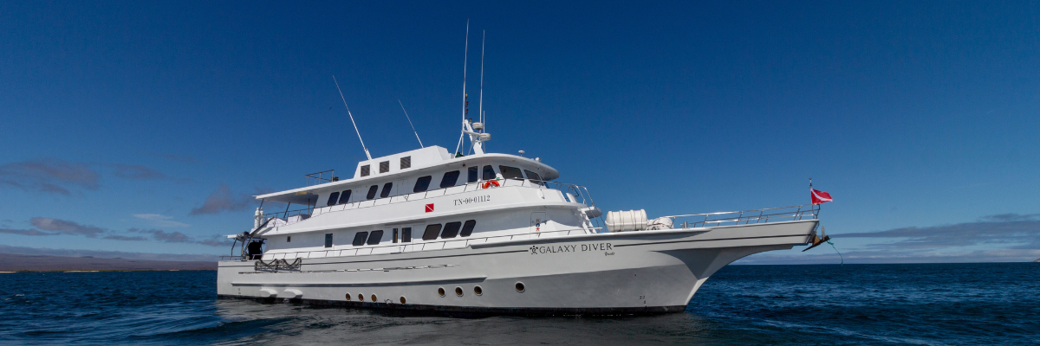

PM: BACHAS
Bachas, named after the mispronounced "barges" left by the Americans during WWII, begins your final day. At low tide, the iron skeletons of the barges can still be spotted buried in the white sand. This spot is one of the most crucial sea turtle nesting grounds in the Galapagos islands from November to May. Several small saltwater lagoons are often home to flamingoes, herons, and other aquatic birds.

Following your visit to Bachas, you will be transferred to the airport for your flight back to mainland Ecuador, concluding your unforgettable Galapagos journey.
Highlights: American flamingoes, white-cheeked pintails, sandpipers, lava gulls, and blue-footed boobies.
Meals | L / D
Trail | 1,6 km / 1 mi
Level | 1
Activities | Wet landing and hiking

Day 2 – Sunday

AM: BARTOLOME
Stand atop Bartolome Island for unparalleled views of the lunar-like landscape, punctuated by scattered volcanic cones, Pinnacle Rock, and the bay of Sullivan. Bartolome is a jewel in the Galapagos crown and home to a vibrant population of penguins.
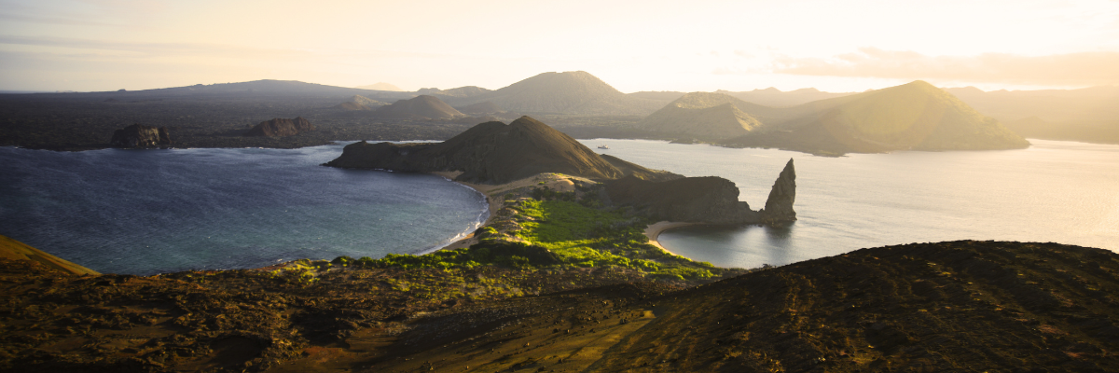
Snorkeling Experience: A swim or snorkel from the beach opens up an underwater playground renowned in the Galapagos. Penguins, a multitude of fish, colorful invertebrates, sea lions, turtles, rays, and reef sharks make this snorkeling experience unforgettable.
Highlights: Galapagos penguins, volcanic landscapes, Pinnacle rock, blue-footed boobies, herons, sea lions, sharks.
Trail | 1,5 km / 0,9 mi
Level | 2
Activities | Dry landing and hiking

AM: SULLIVAN BAY
Step back in time at Sullivan Bay, an open book to the volcanic birth of these islands. Traverse the well-preserved Pahoehoe lava field, studying its delicate, unique textures. The seemingly lifeless landscape gradually unveils a resilience of nature, with pioneer plants, lava lizards, and tiny birds emerging on careful observation. Keep your eyes on the shoreline for resident penguins, pelicans, and oystercatchers.
Snorkeling Experience: A dip in the water here starkly contrasts the barren land. The coral sand beach and the dinghy access point reveal a marine world with fish schools, Galapagos penguins, reef sharks, turtles, and rays.
Highlights: Pahoehoe lava, Galapagos penguins, oystercatchers, Galapagos hawks.
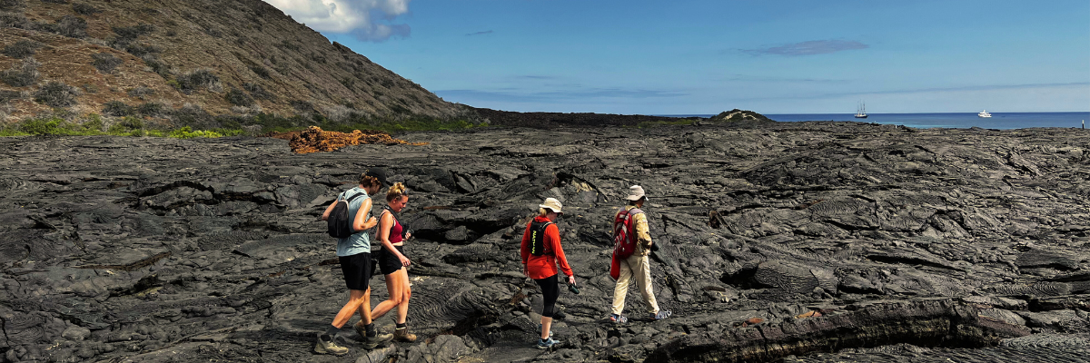
Meals | B / L / D
Trail | 2,2 km / 1,4 mi
Level | 5
Activities | Dry landing and hiking

Day 3 – Monday

AM: SOUTH PLAZAS ISLAND
Begin your day with a visit to South Plazas Island, one of the smaller yet vibrant islands in the Galapagos. This island is renowned for its extraordinary flora, including towering cacti and the striking Sesuvium plant, which changes from green to bright red during the dry season. South Plazas is also home to a large colony of land iguanas, which are often seen lounging under the cacti or wandering around. The steep cliffs on the southern part of the island provide a haven for various seabirds, including swallow-tailed gulls and red-billed tropicbirds. Sea lions frequent the coastline and offers an excellent opportunity to observe their playful antics in the water.
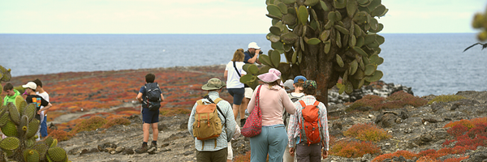
Highlights: Land iguanas, Sesuvium plants, cacti, sea lions, swallow-tailed gulls, red-billed tropicbirds.
Trail | 1 km / 0.6 mi
Level | 2
Activities | Dry landing, hiking

PM: SANTA FE ISLAND
In the afternoon, set off to explore Santa Fe Island, known for its picturesque bay and turquoise waters, perfect for swimming and snorkeling. The island hosts a healthy population of the larger species of land iguanas unique to Santa Fe. Watch for these magnificent creatures as you walk through the giant prickly pear cactus forest. The island's calm, clear waters are ideal for spotting an array of marine life, including sea turtles, rays, and colorful schools of fish. Santa Fe also offers a chance to see the Galapagos hawk and various endemic finches.
This day offers a blend of terrestrial and marine exploration, showcasing the diverse landscapes and wildlife the Galapagos Islands are famous for.
Highlights: Santa Fe land iguanas, prickly pear cactus, sea turtles, Galapagos hawk, snorkeling opportunities.
Trail | 1.5 km / 0.9 mi
Level | 2
Activities | Wet landing, hiking, snorkeling

Day 4 – Tuesday

AM: CERRO BRUJO
Start your day at Cerro Brujo, a breathtaking white sand beach on San Cristobal Island's northern coast. This beach is one of the first sites visited by Charles Darwin. It's an exquisite spot for walking and enjoying the scenery, with its powdery white sand and turquoise waters. The area is home to a large sea lion colony, and the nearby lagoon often hosts several bird species, including pelicans and blue-footed boobies. The clear waters also make it an ideal spot for snorkeling, where you can encounter rich marine life.
Beach and Snorkeling Experience: Stroll along the white sands of Cerro Brujo, enjoy close encounters with sea lions, and explore the vibrant underwater world.
Highlights: White sand beach, sea lions, pelicans, blue-footed boobies, snorkeling opportunities.
Trail | 0.5 km / 0.3 mi
Level | 1
Activities | Wet landing, beach walking, snorkeling

PM: PUNTA PITT
In the afternoon, head to Punta Pitt, located on the eastern end of San Cristobal Island. This unique site is the only place in the Galapagos where you can see all three species of boobies and two species of frigate birds. The trail here offers a challenging hike up a steep path but rewards with stunning views of the coastline. The beach area is also a great spot for snorkeling and swimming, offering a chance to see various marine life.
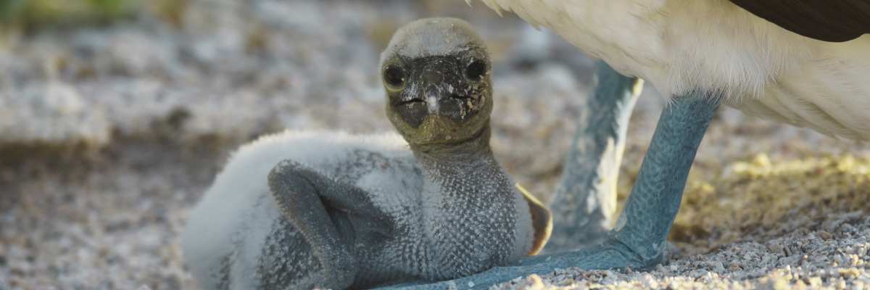
Hiking and Wildlife Observation: Explore the rugged terrain of Punta Pitt and witness the diverse birdlife, including all three booby species and frigate birds.
Highlights: Three booby species (Blue-footed, Red-footed, Nazca), two frigate bird species, stunning views, and snorkeling opportunities.
This day provides a rich experience of San Cristobal Island's diverse landscapes and wildlife, offering both relaxation on a beautiful beach and an adventurous hike with unique wildlife encounters.
Meals | B / L / D
Trail | 1.5 km / 0.9 mi
Level | 3
Activities | Dry landing, hiking, snorkeling

Day 5 – Wednesday

AM: HIGHLANDS
Embark on a highlands adventure. A bus journey brings you to the verdant highland forests, home to Galapagos Giant tortoises. You'll find these impressive creatures, weighing up to 300 kg/600 lbs, casually grazing or lounging in freshwater ponds. The highlands also host a variety of bird species seldom seen in the lowlands. Depending on your itinerary, explore a lava tunnel and delve into the geological history of these volcanic islands.

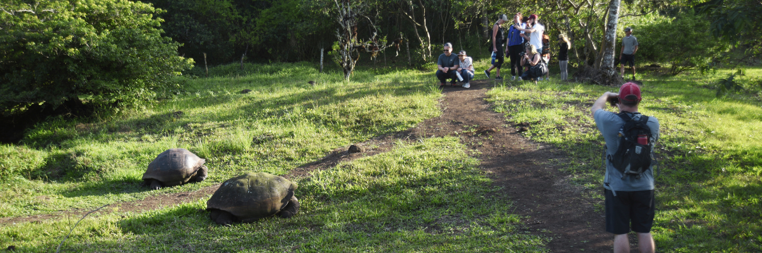
Highlights: Giant tortoises, Darwin finches, barn owls, white-cheeked pintails, Galapagos flycatchers, Lava tunnels.

Meals | B
Trail | 1-1,5 km / 0.6-0.9 mi
Level | 1
Activities | Dry landing and hiking

As the day winds down, prepare for your return to the Ecuador mainland. Reflect on the extraordinary experiences and memories created as you journey back. The return trip is a time to relax and ponder the unique ecosystems and incredible wildlife you've encountered, leaving the enchanted islands behind but taking a piece of their magic.
This concludes your remarkable journey through the Galapagos, filled with awe-inspiring encounters with nature's wonders, leaving you with a deeper appreciation for the delicate balance of our planet's ecosystems.

Glossary
Meals | Breakfast | B | Hiking Effort | Level 1 | Easy
 | Lunch | L |  | Level 2 | Moderate
 | Dinner | D |  | Level 3 | Hard

