NATURALIST ITINERARY

8 DAYS / 7 NIGHTS YACHT

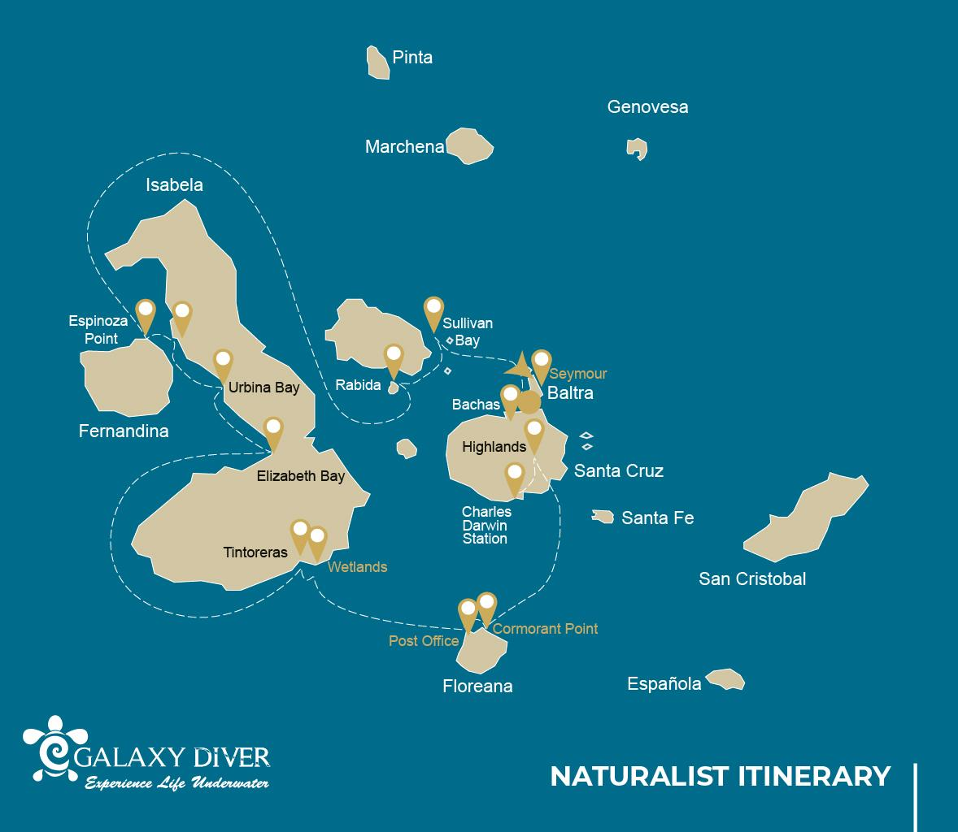

 |  |  |  | HIKING | SNORKEL | PANGA RIDE | KAYAK
8 DAYS CRUISE "NAT" | WEDNESDAY | PM | Santa Cruz: Bachas Beach | •
 | THURSDAY | AM | Santiago Islands: Sullivan Bay | • | • | •
 |  | PM | Rabida: Rabida | • | • | • | •
 | FRIDAY | AM | Fernandina: Espinoza Point | • | •
 |  | PM | Isabela: Tagus Cove | • | • | • | •
 | SATURDAY | AM | Isabela: Urbina Bay | • | •
 |  | PM | Isabela: Elizabeth Bay |  |  | • | •
 | SUNDAY | AM | Isabela: Tintoreras | • | • | •
 |  | PM | Isabela: Wetlands | •
 | MONDAY | AM | Floreana: Post Office Bay | • | •
 |  | PM | Floreana: Cormorant Point | • | • | • | •
 | TUESDAY | AM | Santa Cruz: Highlands | •
 |  | PM | Santa Cruz: Charles Darwin Station | •
 | WEDNESDAY | AM | Seymour: Seymour | •

Day 1 – Wednesday / - Arrival at the Gateway to the Enchanting Galapagos Islands
Welcome to the Galapagos Islands, where today marks the beginning of our adventure onboard the Galaxy Diver liveaboard yacht. Our journey starts with our arrival at Seymour Airport, also known as Baltra Airport, located on Baltra Island. As we step off the plane, we'll be greeted by our guide and the friendly staff of the Galaxy Diver, who will help us with our luggage and transfer us to the Galaxy Diver.
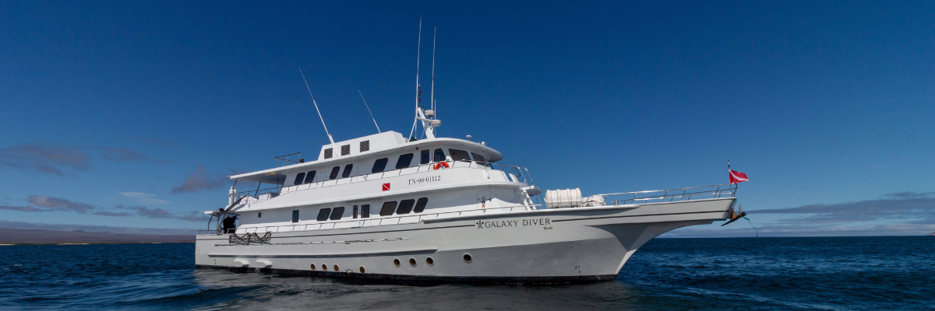
Then, we'll enjoy a delicious lunch and settle into our cabins. Bachas gets its name from the remains of two large barges (mispronounced by locals as “bachas”) left by the Americans during WWII. At low tide, you can still see the iron skeletons of the barges buried in the white sand. From November to May, this place is also one of the most important sea turtle nesting grounds in the entire Galapagos islands. There are also several small saltwater lagoons where we often see flamingoes, herons, and other aquatic birds.
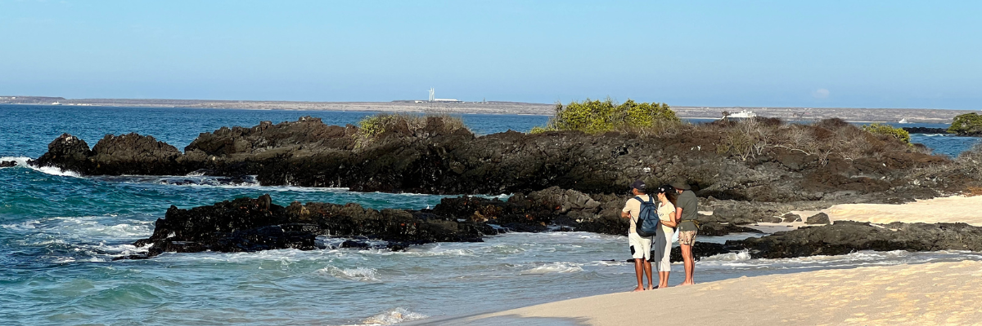

Meals included | Lunch and Dinner
Lodging | Galaxy Diver Yacht
Trail PM | 1.6 km / 1 mi
Highlights | American flamingoes, white-cheeked pintails, sandpipers, lava gulls, blue-footed boobies

Day 2 – Thursday / Sullivan Bay & Rabida
Embark on a journey of discovery as you hike amidst the volcanic islands, each step unveiling the mysteries of their formation. Here, you'll traverse an exceptionally preserved Pahoehoe lava flow—Marvel at its intricate textures – a sight restricted to only a handful of global locations. Though the landscape may initially seem devoid of life, a closer inspection will reveal nature's resilience. Spot the pioneer plants, the darting lava lizards, and the avian inhabitants, small yet full of life.
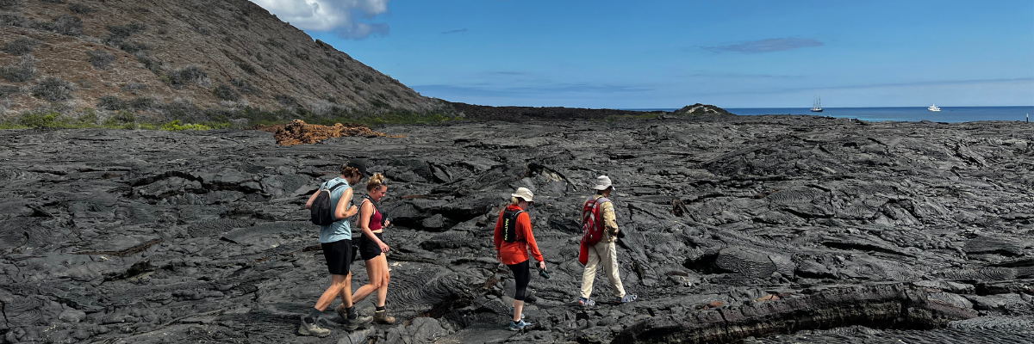
Next, exchange your hiking boots for flippers as the morning invites you to a snorkeling adventure. Either plunge into the clear waters from the pristine coral sand beach or swim from the dinghies. As you submerge, transition into an aquatic wonderland teeming with biodiversity. Schools of vibrant fish, playful Galapagos penguins, stealthy reef sharks, graceful turtles, and gliding rays welcome you into their world.
We then go to Rábida, a petite island celebrated for its iron-rich reddish lava rocks, a distinct sight unlike any other. The island's crimson beach is home to a bustling colony of sea lions. We'll also explore a quaint saltwater lagoon frequented by ducks, stilts, and, occasionally, flamboyant flamingos. A trail beckons inland, promising breathtaking views of the beach and lagoon. Stay on the lookout for Darwin finches, flycatchers, and mockingbirds. As you approach the cliffs by the coast, anticipate encounters with Nazca and blue-footed boobies, brown noddy, herons, and two species of sea lions: Galapagos and fur seals.
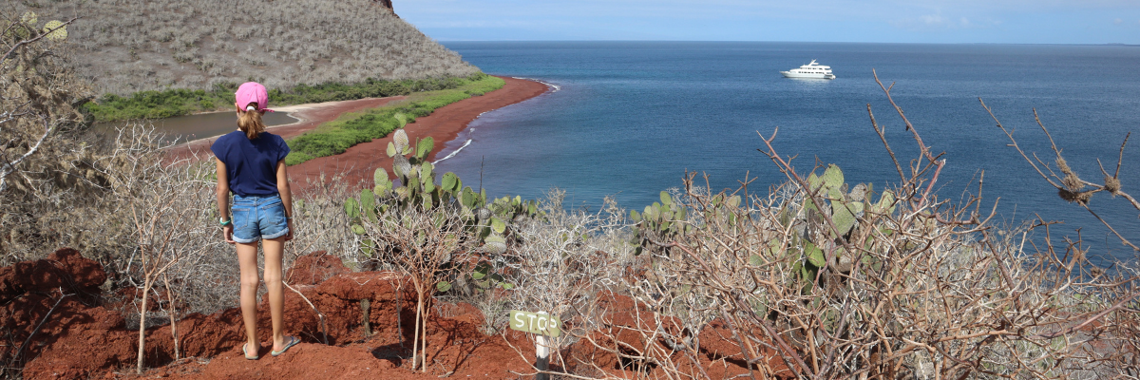
As the afternoon sun shines, a second snorkeling expedition beckons. Starting from the beach, you'll delve into a sheltered rocky area, an aquatic paradise for fish, sea lions, and reef sharks—Marvel at the intricate diversity of small invertebrates clinging to the vertical underwater walls.
This voyage isn't merely a trip; it's a plunge into an ecosystem that whispers the tales of our planet's past and present. With every step on land and flipper stroke underwater, you are not just a traveler but a silent observer of nature's unfathomable wonders. We encourage you to take this journey, to live these stories, and to find your own amidst these volcanic islands.
Meals included | Breakfast, Lunch, and Dinner
Lodging | Galaxy Diver Yacht
Trail AM | 2,2 km / 1,4 mi
Trail PM | 2 km / 1,2 mi
Highlights | Pahoehoe lava, Galapagos penguins, oystercatchers, Galapagos hawks, Red-sand beach, Galapagos sea lions, flycatchers, Darwin finches, Galapagos mockingbirds, ducks, flamingoes.

Day 3 – Friday / Espinoza Point & Tagus Cove
Find yourself at the foot of an awe-inspiring, active volcano in the Galapagos National Park, a place that houses the extraordinary. As you step ashore, you'll be greeted by countless marine iguanas from the largest known colony while sea lions and their young playfully cavort in nearby tide pools. Along the coast, spot the flightless cormorants unique to the archipelago's western parts. Home to a multitude of species, from herons to sea turtles, Punta Espinosa thrives due to its plankton-rich waters. Keep an eye on the mangroves for Galapagos hawks perched high, scouting for their next meal.
Take advantage of the snorkeling around Punta Espinosa, a haven for diverse marine life thanks to the nutrient-rich waters. You'll marvel at the marine iguanas feeding underwater amidst the abundant seaweeds. Following a cormorant on a high-speed fish chase through the reef makes for an unforgettable snorkeling experience.
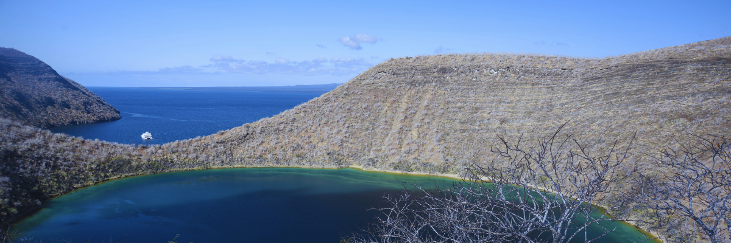
Next, venture to Tagus Cove, a historical site visited by Charles Darwin. A trail through the dry Palo Santo forests introduces you to Darwin finches and mockingbirds while offering splendid views of Darwin's lake and northern Isabela's massive volcanoes. A boat tour along the shoreline allows sightings of penguins, cormorants, marine iguanas, and the unique Galapagos martin, an endemic bird species that are among the island's most endangered.
The snorkeling around Tagus Cove is just as captivating, with nutrient-rich waters teeming with sea turtles, diverse fish, and penguins feasting on anchovies. Expect to see cormorants underwater as they weave through the reefs chasing fish.
Meals included | Breakfast, Lunch, and Dinner
Lodging | Galaxy Diver Yacht
Trail AM | 1,6 km / 1 mi
Trail PM | 2,6 km / 1,6 mi
Highlights | Galapagos hawks, marine iguanas, flightless cormorants, penguins, sea turtles, sea lions, herons, oystercatchers, shorebirds, sally light-foot crabs, sea stars

Day 4 – Saturday / Urbina Bay & Elizabeth Bay
Venture into the past as you explore the site renowned for its dramatic uplifting in the 1950s, where a large part of the coast was thrust upwards, revealing a vast area once submerged underwater. Trace the history embedded in the trail as you discover small shells and corals, evidence of an aquatic past over sixty years old. The area is a hub of life, home to land iguanas and, seasonally, giant tortoises. Look to the skies or treetops to spot Galapagos hawks.
Don your snorkeling gear and head to the beach to encounter sea turtles, cormorants, and penguins. Abundant fish life thrives in these waters, making your underwater exploration all the more exciting.
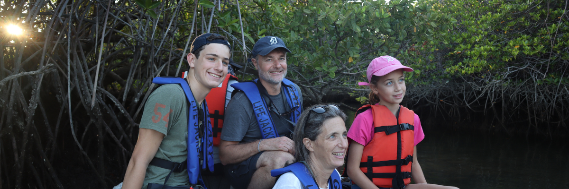
Next, experience the serene beauty of Elizabeth Bay, a protected bay framed by towering mangroves and stark lava fields. As there's no trail here, explore the area on a dinghy tour, navigating through life-teeming channels, pools, and coves. This spot is among the best to see Galapagos penguins, albeit in smaller numbers due to the overall population of only about 3,000. The area also hosts flightless cormorants, blue-footed boobies, and pelicans, especially seen fishing in these nutrient-rich waters. Sea turtles and rays are also plentiful here.
Meals included | Breakfast, Lunch, and Dinner
Lodging | Galaxy Diver Yacht
Trail AM | Short trail = 1,2 km / 0,7 mi | Long trail = 3 km / 1,8 mi
Highlights | Galapagos hawks, land iguanas, Galapagos mockingbirds, Darwin finches, flycatchers, sea turtles, rays, Galapagos penguins, flightless cormorants, and herons.

Day 5 – Sunday / Tintoreras & Isabela Wetlands
Located near Puerto Villamil, the primary settlement in Isabela, occupying merely 3% of the island's total landmass, is a remarkable little islet brimming with wildlife. Isabela, the largest island in the Galapagos archipelago, exhibits a unique seahorse shape and hosts an array of natural wonders.
Tintoreras, the islet near Puerto Villamil, is home to expansive colonies of marine iguanas and sea lions. You can observe rays and sea turtles gracefully maneuvering through the shallow channels and get an up-close look at the local 'Tintoreras,' or reef sharks. The island also hosts a diverse bird population, including common herons and gulls. With some luck, you might even spot a Galapagos penguin, a species represented by a few individuals in the area.
Continuing the adventure, you will reach the wetlands of Villamil, a vast network of lagoons, channels, and coves neighboring the town. Surrounded by mangroves, these saltwater lagoons serve as sanctuaries for various bird species, such as American flamingos, white-cheeked pintails, gallinules, stilts, and other shorebirds. The main trail begins in the town and concludes at the Tortoise Breeding Center, offering a rewarding trek for nature lovers.
Meals included | Breakfast, Lunch, and Dinner
Lodging | Galaxy Diver Yacht
Trail AM | 1,1 km / 0,7 mi
Trail PM | 1,2 km / 0,8 mi
Highlights | Reef sharks, Galapagos penguins, marine iguanas, sea lions, Galapagos mockingbirds, Darwin finches, herons, gulls, American flamingoes, gallinules, ducks, and stilts.

Day 6 – Monday / Post Office Bay & Cormorant Point
Floreana Island, renowned for its intriguing tales of German settlers and a baroness in the late 1920s and 1930s, is steeped in mystery, with stories of unsolved assassinations and disappearances.
In the morning, head to Post Office Bay, a popular anchoring spot for whalers in the past who visited the highlands for fresh water and tortoises. This site was part of a unique mailing system established over 200 years ago, where sailors would leave messages for other ships in a barrel near the beach. This historic mail system remains active, allowing you to send postcards from the Galapagos. Apart from a stunning beach and a lava tunnel, you can enjoy a dinghy tour to spot sea lions, green sea turtles, shorebirds, small sharks, and if lucky, Galapagos penguins. Snorkeling offers encounters with sea turtles, rays, a variety of fish, and possibly even a Galapagos penguin.
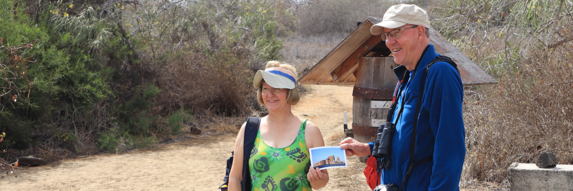
In the afternoon, venture to Cormorant Point, located in Floreana's north, famous for its large coastal lagoon housing American flamingoes, white-cheeked pintails, black-necked stilts, and other shorebirds. Admire the pristine white sand beach, a significant nesting ground for green sea turtles, and keep an eye out for rays and reef sharks. Recent years have seen the arrival of blue-footed boobies, now breeding by the trail. It's also an excellent trail for exploring endemic plants.
Meals included | Breakfast, Lunch, and Dinner
Lodging | Galaxy Diver Yacht
Trail AM | 0,7 km / 0,4 mi
Trail PM | 1,6 km / 1 mi
Highlights | Sea lions, sea turtles, finches, shorebirds, marine iguanas, penguins, American flamingos, blue-footed boobies, frigatebirds, tropicbirds, Galapagos shearwaters, sea turtle nesting site, coral-sand beach.

Day 7 – Tuesday / Highlands & Charles Darwin Station
Embark on a morning bus journey to the lush highland forests of the Galapagos. This region is home to the iconic Galapagos Giant Tortoises and a variety of unique bird species that favor the highlands over the lowlands. You might also explore an intriguing lava tunnel, learning about the volcanic origins of these islands.
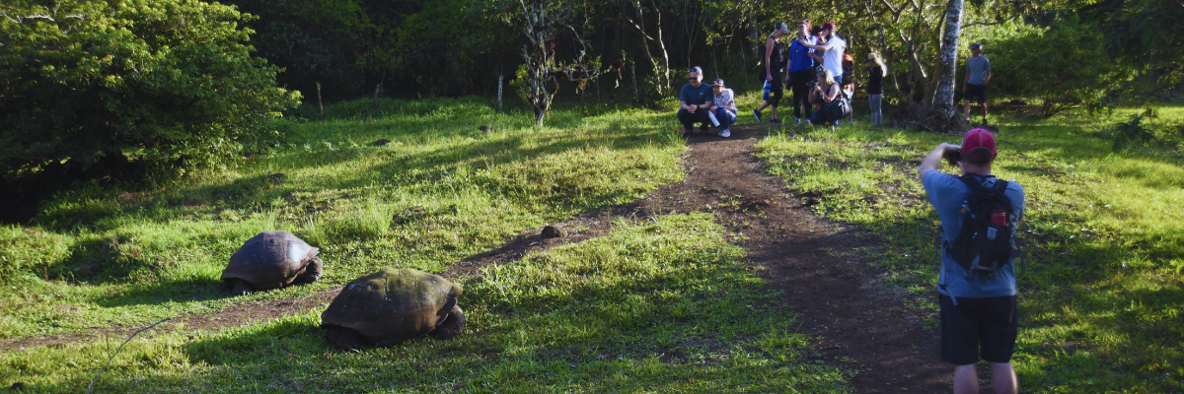
In the afternoon, visit the Charles Darwin Station, a hub of conservation efforts working tirelessly to protect the Galapagos' biodiversity. Learn about their ambitious projects, such as the captive breeding program for giant tortoises, while walking through a scenic dry native forest, home to an array of native plants and numerous endemic bird species.
Meals included | Breakfast, Lunch, and Dinner
Lodging | Galaxy Diver Yacht
Trail AM | 1 - 1,15 km / 0,6 – 0,9 mi
Trail PM | 2 km / 1,2 mi
Highlights | Giant tortoises, Darwin finches, barn owls, white-cheeked pintails, Galapagos flycatchers, land iguanas, Galapagos mockingbirds, yellow warblers, and Lava tunnels.

Day 8 – Wednesday / Seymour & Return to Ecuador Mainland
Start your final day with a visit to Seymour Island. This vibrant hub of wildlife boasts impressive colonies of magnificent and great frigatebirds, often spotted displaying their distinct red gular pouches. Blue-footed boobies are no strangers to performing their famed dance amidst open areas, while swallow-tailed gulls can be seen resting on cliff edges. Inland, you'll encounter land iguanas while their marine counterparts bask near the sea, often alongside body-surfing sea lions.
Following your morning excursion, you'll be transferred to the airport for your flight back to mainland Ecuador.

Meals included | Breakfast
Trail AM | 1,4 km / 0,8 mi
Highlights | Galapagos sea lions, blue-footed boobies, magnificent and great frigatebirds, land and marine iguanas, swallow-tailed gulls, shearwaters, and Darwin finches.

