Western Galapagos Wildlife & Volcanic Wonders

Itinerary B / 6 Days – 5 Nights

 |  |  |  | HIKING | SNORKEL | PANGA RIDE | PADDLE  BOARD | KAYAK
6 DAYS "B" | WEDNESDAY | PM | Santa Cruz: Highlands | •
 | THURSDAY | AM | Isabela: Tintoreras | • |  | •
 |  | PM | Isabela: Wetlands & Interpretation Center | • | • | • | •
 | FRIDAY | AM | Isabela: Moreno Point | • | • | •
 |  | PM | Fernandina: Mangle Point | • | • | •
 | SATURDAY | AM | Fernandina: Espinoza Point | • | • | •
 |  | PM | Isabela: Tagus Cove | • | • | • | • | •
 | SUNDAY | AM | Santiago: Egas Point | • | •
 |  | PM | Santiago: Chinese Hat | • | • | • | • | •
 | MONDAY | AM | Santa Cruz: Black Turtle Cove | • | •

Day 1 – Wednesday

AM: TAKEOFF TO BALTRA AIRPORT
Embark on an unforgettable adventure to the Galapagos Islands, starting with your arrival at Baltra airport. Our expert naturalist guide from the National Park will eagerly await your arrival to introduce you to the wonders ahead.
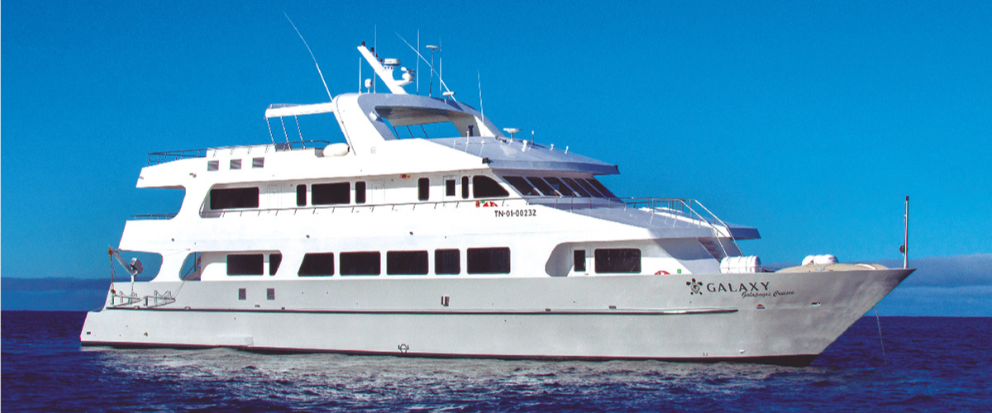

PM: HIGHLANDS
Whether you're commencing your exploration from Baltra or Puerto Ayora, a comfortable bus ride will usher you into the verdant embrace of the highlands. En route, we'll pause at a reserve, where you'll step into lush highland forests to seek out Galapagos Giant tortoises in their natural habitat. Witness these gentle titans - some weighing more than 300 kg / 600 pounds - as they graze and recline in tranquil freshwater ponds. These highlands are also a sanctuary for many bird species seldom found in the lowlands, such as finches (tree, woodpecker, and vegetarian), flycatchers, and numerous waterbirds. Depending on your itinerary, you'll also visit a lava tunnel. Here, you'll delve into the fascinating geological history of the Galapagos, understanding how ancient volcanic eruptions crafted these extraordinary formations.
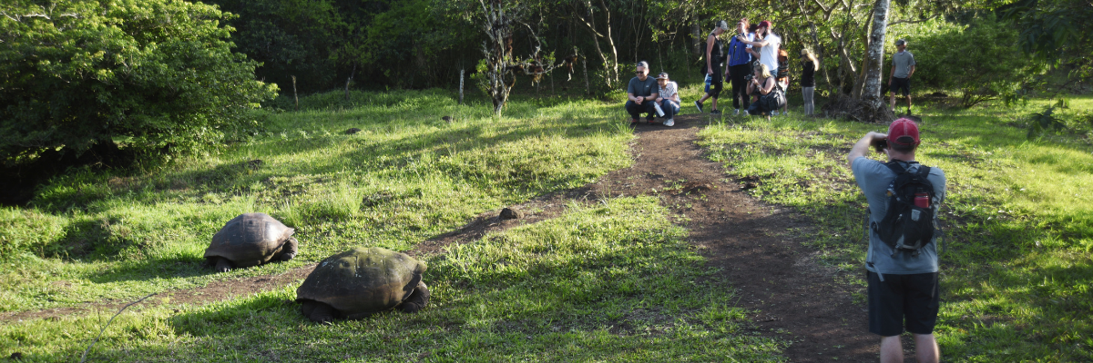
Highlights: Giant tortoises, Darwin finches, barn owls, white-cheeked pintails, Galapagos flycatchers, Lava tunnels.
Meals | L / D
Trail | 1 - 1,5 km / 0,6 – 0,9 mi
Level | 1
Activities | Dry landing and hiking

Day 2 - Thursday

AM: TINTORERAS
Start your morning on Isabela Island, embarking on a unique adventure at Tintoreras, a cluster of small isles teeming with wildlife. Sail through crystal-clear waters and discover a vibrant underwater world inhabited by white-tipped sharks, colorful tropical fish, and starfish.
Snorkeling: Dive into the marvelous marine world of Isabela. Swim alongside sea turtles, manta rays, and, if you’re lucky, Galapagos penguins.
Highlights: Tintoreras, white-tipped sharks, sea turtles, manta rays.
Trail | 6 km / 3.7 mi
Level | 2
Activities | Wet landing, hiking, snorkeling

PM: ISABELA ISLAND WETLANDS & INTERPRETATION CENTER
In the afternoon, explore the wetlands of Isabela Island, a vital ecosystem for the biodiversity of the Galapagos. These trails take you through mangroves, saline lagoons, and beaches, where you can spot flamingos, blue-billed ducks, and other aquatic birds. Conclude the day at the Interpretation Center, discovering the natural and human history of the islands, their conservation, and the ongoing efforts to protect this World Heritage Site.
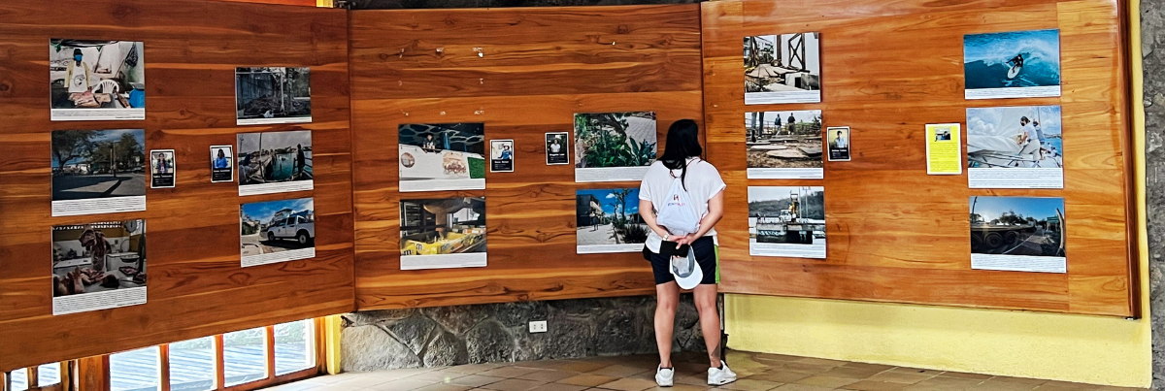
Highlights: Wetlands, mangroves, flamingos, blue-billed ducks, Interpretation Center.
Meals | B / L / D
Trail | 3 km / 1.86 mi
Level | 1
Activities | Hiking

Day 3 – Friday

AM: MORENO POINT
Begin your day at the seemingly barren yet enchanting landscape of Moreno Point, a vast tableau of lava fields that unfolds into a tapestry of life. As you venture inland, discover brackish lagoons acting as life's oasis, teeming with flamingos, gallinules, ducks, and herons. Along the coastline, keep an eye out for the playful penguins, marine iguanas, flightless cormorants, blue-footed boobies, sea lions, oystercatchers, and a chorus of other shorebirds.
Snorkeling Experience: Submerge yourself in the clear waters for a closer look at sea turtles, cormorants, and an array of fish species. You might even spot the elusive sea horse in the lengthy seaweeds if you gaze carefully.

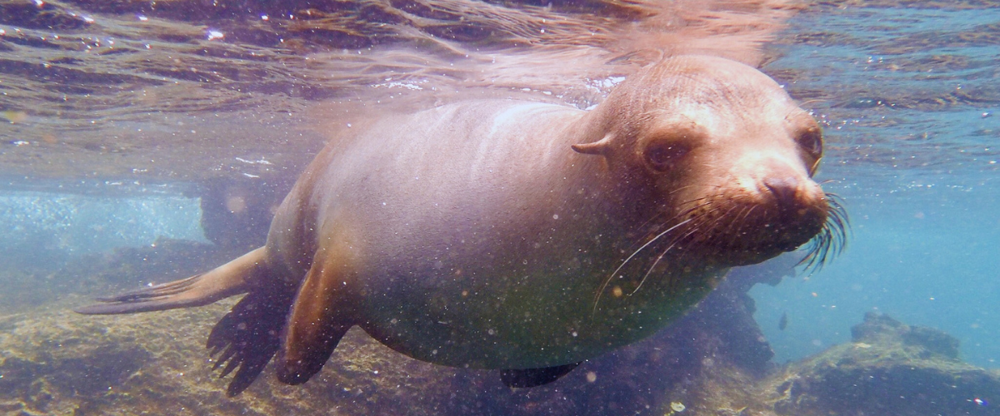
Highlights: American flamingoes, ducks, gallinules, penguins, cormorants, marine iguanas, sea lions, Galapagos mockingbirds, and Darwin finches.
Trail | 1,6 km / 1 mi
Level | 3
Activities | Dry landing and hiking

PM: MANGLE POINT
Begin your day at Mangle Point on the pristine Fernandina Island, one of the Galapagos's most untouched and ecologically pure islands. This location offers a spectacular mangrove ecosystem, a haven for wildlife. As your boat gently navigates through the clear waters, observe the intricate mangrove roots where marine turtles and rays often hide. The calm and shallow waters make this an ideal spot for snorkeling, offering a chance to swim alongside sea turtles, various species of rays, and abundant tropical fish.
Mangle Point presents a unique opportunity to witness the symbiosis between the mangrove forests and the marine environment, offering a serene and intimate experience with nature.
Snorkeling Experience: Immerse yourself in the tranquil waters of Mangle Point—experience close encounters with the diverse marine life that thrives among the mangroves and coral reefs.
Highlights: Mangrove ecosystem, sea turtles, rays, tropical fish.
Meals | B / L / D
Trail | N/A (mainly a water-based activity)
Level | 1
Activities | Panga (dinghy) ride, snorkeling

Day 4 – Saturday

AM: ESPINOZA POINT
Begin your day at Espinoza Point, located at the base of an imposing volcano - the most active in the Galapagos islands. This site, one of the crown jewels of the Galapagos National Park, presents a unique spectacle right from the moment you step ashore. Hundreds of marine iguanas, forming the largest colony of the species, greet you upon arrival. Sea lions lounge on the beaches, their pups playfully exploring the tide pools. Along the shore, catch sight of flightless cormorants, a species confined to the western areas of the archipelago. Blessed with cold, plankton-rich waters, Punta Espinosa is a sanctuary for diverse species, including herons, pelicans, oystercatchers, sea turtles, shorebirds, and more. Also, keep an eye on the mangroves where Galapagos hawks often perch, scanning for prey.
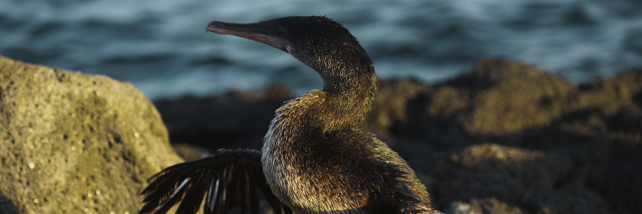
Snorkeling Experience: The nutrient-dense waters around Punta Espinosa attract a myriad of fish and sea turtles. The abundant seaweed makes this spot an ideal location to watch marine iguanas feed underwater. Following a cormorant underwater as it chases fish through the reef will undoubtedly be one of the most incredible snorkeling experiences you'll have on your trip.
Highlights: Galapagos hawks, marine iguanas, flightless cormorants, penguins, sea turtles, sea lions, herons, oystercatchers, shorebirds, and sally light-foot crabs.
Trail | 1,6 km / 1 mi
Level | 2
Activities | Dry landing and hiking

PM: TAGUS COVE
In the afternoon, we visit the historical Tagus Cove, a site Charles Darwin once explored during his travels around the Galapagos islands. Traverse the arid Palo Santo forests, where Darwin finches and mockingbirds make their home, and take in the panoramic views of Darwin’s Lake and the towering volcanoes of northern Isabela.
A boat tour along the shore offers chances to observe penguins, cormorants, marine iguanas, and the rare Galapagos martin - an endemic, petite bird considered one of the most endangered species on the island.
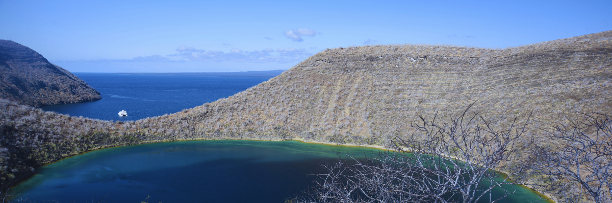
Snorkeling Experience: The nutrient-rich waters around Tagus Cove draw in sea turtles, a rich diversity of fish species, and penguins feasting on large schools of anchovies. Watching cormorants dart underwater as they chase fish through the reef is a common sight.
Highlights: Galapagos hawks, marine iguanas, flightless cormorants, herons, penguins, sea turtles, and sea stars.
Meals | B / L / D
Trail | 2,6 km / 1,6 mi
Level | 3
Activities | Dry landing and hiking

Day 4 – Sunday

AM: EGAS PORT
Despite its misleading name, there isn't a traditional "port" at Puerto Egas, yet some remnants of past attempts to colonize the island during the 1960s can still be seen. The trail here follows the coastline, an area rich in wildlife. You will see marine iguanas basking in the sun everywhere you turn, along with Galapagos sea lions, herons, oystercatchers, and many shorebirds. Towards the trail’s end, you'll encounter "the grottos,” home to a small colony of the elusive endemic Galapagos fur seal, much more challenging to spot than its cousin. As recently as 2019, land iguanas were reintroduced to the area, so keep an eye out for these impressive reptiles, which had been extinct from Santiago for over a century.
Snorkeling Experience: A snorkeling session from the beach will lead you to an area of rocky bottoms, excellent for observing fish, turtles, and reef sharks. Sea lions often frequent this area and are typically open to interacting with divers.
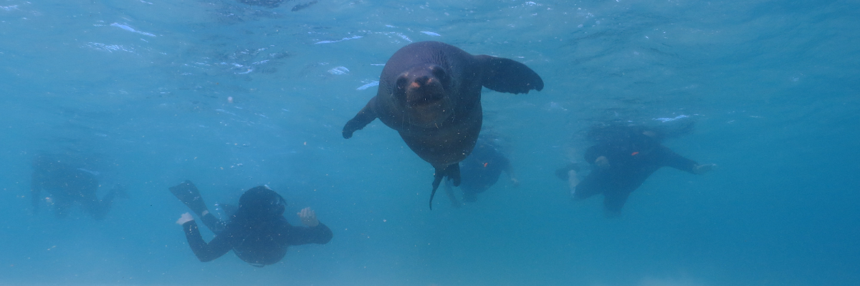
Highlights: Galapagos sea lions, Galapagos fur seals, oystercatchers, marine & land iguanas, Galapagos hawks, herons, shorebirds, Darwin finches, Galapagos doves.
Trail | 2,3 km / 1,4 mi
Level | 1
Activities | Wet landing and hiking

PM: CHINESE HAT
Welcome to the perfectly symmetrical volcanic cone of Chinese Hat! Separated from Santiago by a slender channel, this idyllic islet is framed by turquoise waters, coral sand beaches, and dark lava rocks – an unexpected haven for penguins. A shore trail brings you up close to a small colony of sea lions.

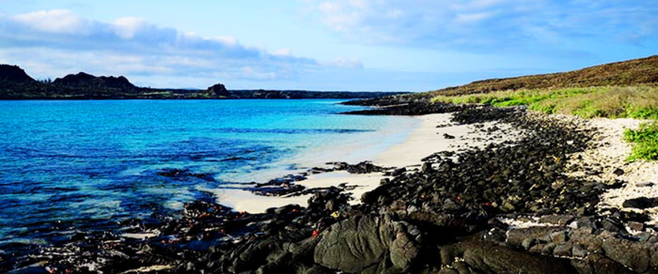
Snorkeling Experience: Experience a world of vividly colored fish, sleek reef sharks, and perhaps a swift penguin chasing after a school of anchovies. It's a mesmerizing underwater spectacle you want to take advantage of.
Highlights: Galapagos sea lions, Galapagos penguins, lava tubes, oystercatchers, Galapagos hawks.
Meals | B / L / D
Trail | 1,3 km / 0,8 mi
Level | 3
Activities | Wet landing and hiking

Day 6 – Monday

AM: BLACK TURTLE COVE
We dive into our Galapagos adventure at Black Turtle Cove, aptly named for the thriving "Tortugas negras" population or green sea turtles. We navigate this natural sanctuary on dinghies, cruising amidst serene mangrove forests and tranquil water channels. Expect sightings of reef sharks, diverse ray species, and a plethora of bird species, including herons, pelicans, and boobies. Remember, this magical cove is a significant breeding ground for turtles and a nursery for various shark species!
As the day winds down, prepare for your return to the Ecuador mainland. Reflect on the extraordinary experiences and memories created as you journey back. The return trip is a time to relax and ponder the unique ecosystems and incredible wildlife you've encountered, leaving the enchanted islands behind but taking a piece of their magic.
This concludes your remarkable journey through the Galapagos, filled with awe-inspiring encounters with nature's wonders, leaving you with a deeper appreciation for the delicate balance of our planet's ecosystems.
Highlights: White-tipped and black-tipped reef sharks, green sea turtles, rays, herons, blue-footed boobies, and mangroves.
Meals | B
Level | 1
Activities | Panga Ride

Glossary
Meals | Breakfast | B
 | Lunch | L
 | Dinner | D
Hiking Effort | Level 1 | Easy
 | Level 2 | Moderate
 | Level 3 | Hard

